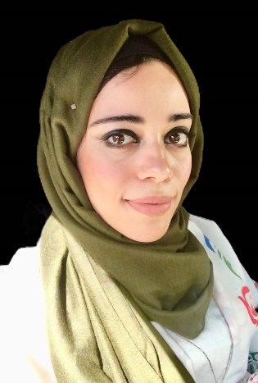
Dr. Mustafa
------------------------------------------------------------
Personal Information
Date of birth: 18/9/1987
Place of birth: Abu Dhabi - UAE
Nationality: Egyptian
Marital status: Single
E-mail address: Mustafa.380689@2freemail.com

Academic Qualification:
- Graduated from Palestine Secondary School, Abu Dhabi – UAE year 2005, 98.8%
- IELTS certificate – score: 7
- Degree of bachelor of dental medicine and surgery, Alexandria University, Faculty of dentistry, Egypt in July 2010 with the general grade of very good with honor.
- Had obtained 223 contact hours fellowship in advanced aesthetic and restorative dentistry (223 contact hours), Genoa University, Italy 03/1/2017.
- Obtained master’s degree in “oral and maxillofacial surgery” 14/11/2017 Alexandria university, Egypt.
- Attended 12 credit hours course in endo rotary instrumentation and obturation, Alexandria dental syndicate, Egypt 2015.
- Attended 60 credit hours course in fixed prosthodontics in dental practice, Alexandria dental syndicate, Egypt 2016.
- Participated in 100 hours theoretical and practical comprehensive course in basic implantology from 5th to 11th of August 2015.

- Acceptance letter from Alexandria Dental Journal for publication of scientific paper entitled: “Effect Of The Use Of The Human Amniotic Membrane In Healing Of Surgically Induced Skin Defects In Rabbits (Histopathological Study) October 18, 2017
- DHA license as GP dentist issued in 8.5.2018.

Experience:
- Contributed and organizer in many medical events and dental conferences.
- Resident doctor in oral and maxillofacial department – Main Hospital of Alexandria University (2013-2016)
- Have been employed in ministry of health in the position of DENTIST since 21/12/2011 to 1/10/2017.
- Worked in Al Madina Medical Centre from 19/5/2015 to 28/5/2016.
- Worked in Sahla Hospital, Alexandria as surgeon dentist from 7/9/2016 to 28/9/2017.
- Medical interpreter in CCAD (Cleveland Clinic Abu Dhabi) since 15th of Nov. 2017.

Skills and Personality characteristics:
- Ambitious qualified dentist with excellent organizational and interpersonal skills.
- Excellent skills pertaining the cosmetic dentistry including: veneers, esthetic crowns, post and core, indirect composite inlays and onlays, direct esthetic composite filling and therapeutic botox injection.
- Doing both minor and major surgeries confidently including: simple extraction, surgical extraction, impaction, oroantral fistula closure, cyst and benign tumor removal, biopsy taking, bone grafting, apicectomy, frenectomy, sulcus deepening, salivary gland stone removal, close and open reduction for fractures in oral and maxillofacial region using wires or plates and screws.
- Keen to secure a position with dynamic and progressive dental practice.
- Excellent patient care skills learned through clinical practice and other hospital related employment.
- Managing appointments and treatment for own set of patients.
- Committed and experienced at working to deadline and following exact procedures.
- Can satisfy the customers and pleased them.
- Honest, humble, straightforward, working under pressure, handle the pressure of work, perseverance, good looking.
Languages: I have good command of both English and Arabic languages (reading, writing and speaking)
Hobbies:
- Drawing
- Reading
- Travelling
- Swimming

