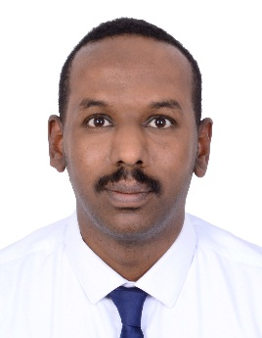
Resume
NAME :- Gafar
Nationality:- Sudanese
BIRTH DAY:- 10/12/1985
HOME : - UAE - Dubai – silicone oasis
Email:- gafar.380786@2freemail.com
HR assistant
Almosa co for bases building material – Saudi Arabia [03/2016 – 03/2018]
- Provide support to the Human Resources Manager on HR related issues.
- Prepares and administers all final settlements of resigning and exiting employees.
- Ensure correct data of employees’ daily attendance and preparation of daily reports as required by project management.
- Assist in resolving salary and timesheet discrepancies of permanent & temporary employees.
- Input personal data of every joining employee & update exiting employees into SMACC software.
- Advise for all cancelation and ensure exit employees have left the country as scheduled.
- Relay the monetary information of the exiting or vacationing employees to Accounts Dept.
- Receives medical certificates and disciplinary forms for input and record.
- Initiates the exit formalities of employees

HR manager
Abu alfadel plaza (retail co) – Khartoum [08/2015 – 2/2016]

Human resources manager
Kuwaiti Specialist hospital - project in patients helping fund organization - Khartoum [1/6/2011 – 7/2015]
• Establish a human resources department to the minimum staff and higher efficiency.
human resources assistant:-
Patients helping fund organization – Khartoum [02/2010 – 6/2011]
  - Carried out all recruitment processes including reaching potential candidates by telephone/email, applicants’ resume screening, interviewing applicants, processed background checks, shortlisting, finalizing hiring and closing vacancies
• Carried out employee orientations and processed new hire paperwork, ensuring compliance with company requirements on time
• Created, organized, updated and maintained personnel files and the HR database
• Managed and coordinated employee training and development programs
• Communicated with management and executives for creation, refreshing and/or interpreting policy changes
• Provided administrative support for all HR functions, including filing, copying, general correspondence and support/preparation for meetings, trainings, orientations, executive travelling, etc.
Key Accomplishments
• Assisted HR Manager in revising the company Policies & Procedures, Onboarding, Visa processing, Payroll, Training, Employee Development and manual in coordination with other staff members
• Successfully coordinated numerous HR events for the staff including “Employees Annual Achievements Day”, multiple guest speaker sessions, seminars, conferences, trainings, employee retreats, etc.
EDUCATION
- Degree of Bachelor of science in computer science with grade (v.good) in Omdurman Islamic university in (28 – June - 2009).
- Master degree in MBA in Sudan international university hr specialist in (19- November -2014) .
skills
- Work under erp system (aswaq – smacc) .
- Microsoft office professional user ( word , excel , power point, access).
- Work with diversity employees.
- Self improvement
- Work under pressure
Language:
Language: English and arabic

