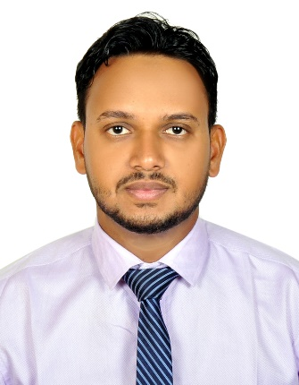
Objectives
To obtain a challenging position that will utilize my skills and experiences and which will also provide me with the opportunity for growth and advancement.

Experience

PUBLIC WORKS AUTHORITY (PWA), DOHA – QATAR
(From 1st march 2016 to March 2018)
- Working as an admin assistant
- Answer phones and transfer to the appropriate staff member
- Organize and schedule appointments
- Write and distribute email, correspondence memos, letters, faxes and forms
- Develop and maintain filing system

QATAR FUEL ADDITIVES COMPANY (QAFAC), DOHA – QATAR
(From 26th November 2012 to 30th February 2016)
- Working as an admin assistant
- Answer phones and transfer to the appropriate staff member
- Organize and schedule appointments
- Write and distribute email, correspondence memos, letters, faxes and forms
- Monitor and maintain office supplies

QATAR UNIVERSITY (QU), DOHA – QATAR
(From 26th June 2012 to 01 November 2012)
- Working as an office assistant
- Answer phones and transfer to the appropriate staff member
- Prepare outgoing mails for distribution

QATAR NATIONAL BANK (QNB), DOHA-QATAR
(From 25th November 2011 to 25th June 2012)
- Working as an office assistant
- Answer phones and transfer to the appropriate staff member
- Greet public and clients and direct them to the correct staff member
- Monitor and maintain office supplies

Company name, Location
Dates From-To

Education

School Name, Location, Degree
You might want to include your GPA here and a brief summary of relevant coursework, awards, and honors

Communication
COMPUTER LITERATE
- Microsoft word
- Microsoft excel
- Microsoft PowerPoint
- Microsoft access

