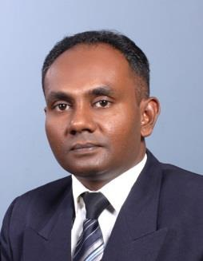  Personal Details:  Date of Birth:  17th June 1978  Marital Status:  Married  Nationality:  Sri Lankan.  Place of Issue:  Sri Lanka.  Visa Status:  VISIT VISA. | CURRICULUM VITAE  Razeen  BSc. (Defence Studies), MBS (Colombo)  E- MAIL: razeen.380824@2freemail.com  ––––––––––––––––––––––––––––––––––––––––––––––––––––––––––––––––––––––––––––––––––––––––––––––––––––––––––––  CAREER OBJECTIVE  To Apply my specialized knowledge & skills in a challenging position whereby my interests and talents can be utilized and developed, in order to benefit the company and assist in my career development within the organization and to seek a job that gives me a chance to express myself.  CAREER RELEVANT ATTRIBUTES  - I joined the Sri Lanka Air Force on 11th October, 1998 through the Kothalawala Defence University and Commissioned as a Pilot Officer. After completing my Bachelor of Science Degree in Management and Technical Science, I joined General Duties Pilot Branch. After that I joined Administrative Branch and served up to the rank of Substantive Squadron Leader. I was discharged from the Sri Lanka Air Force with effect from 09th July 2015.  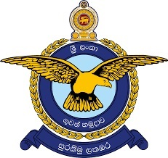  SRI LANKA AIR FORCE.  GUARDIANS OF THE SKIES  Organization : Sri Lanka Air Force  Designation : Commissioned Officer.  Job Profile 1:  - General Administration and Management.  - Personal Management.  - Human Resources Management.  - Financial Management.  - Book keeping.  - Auditing.  - Inventory Control and Management.  - Strategic and Defence Management.  - War Appreciation and Defence Planning.  - Performance of Security Duties.  - Fire Fighting Training and Survival Training.  - Health and Safety Training.  - Training Development and Conducted Lecture Modules to under graduates.  - Sports Administration.  - I have worked as the Operations Manager at Lanmo (Pvt) Ltd. Galle Branch from 22nd October 2015 to 28th February 2017. Lanmo is a Total Solution Provider in the field of construction. As the Operations Manager, I carried out Administrative Works and HR related works.  Job Profile 2 :  - Office Administration and General Administration.  - Human Resource Functions.  - Operational Support and Organizational.  - Coordinating Teams and Staff to requirement of daily requirements.  - Management Support and Coordinating.  - Interactions between Client and Management well as the Service Staff.
Languages Known:  - English  - Tamil  - Sinhala  - Hindi  Interests:  Reading, Traveling, Mountaineering, Watching Movies,  Charity works. | ACADEMIC QUALIFICATION  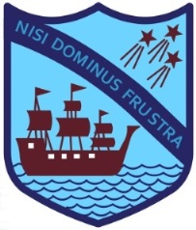  School Attended:  Richmond College, Galle, Sri Lanka  G.C.E. (O/L) in 1994, G.C.E. (A/L) in 1997  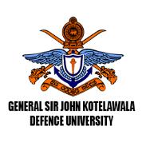  Higher Educational Institutes:  Bachelor of Science (Defence Studies) in Management and Technical Science by Kothalawala Defense University (KDU).  Masters of Business Studies, University of Colombo.  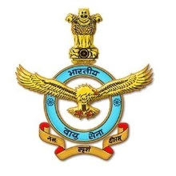  114 Ground Duty Officers Accounts Course at Air Force Academy Hyderabad, India.  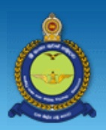  No: 39 Junior Commander’s Course at Junior Command & Staff College, Sri Lanka Air Force Academy, China- Bay, Sri Lanka.  EXTRA CURRICULAR ACTIVITIES  - Scouting: - A President Scout, Past Member of the Rover Crew of Galle District. Represented Sri Lanka in 12th SAARC and 12th Pakistan National Jamboree held in 1994 at Quetta, Pakistan. Present Member of the Richmond College Old Scout Solidarity. Carried out many social activities during the school time and after.  - Mountaineering and Expedition: - Was the first president of Richmond College Mountaineering Association. Participated in all island mountaineering competitions. Represented Sri Lanka First School National Mountaineering Team and able to climb up to Mount Everest Base Camp and Kalapathar Mountain in 1998. Won the School Colours and National Colours for Expeditions and Exploration.  - Sports:-Played Rugby, Football for school in all island level tournaments in all age categories. Played for Kothalawala Defense University Team.  Played Soccer at the Air Force for the Inter Unit Tournaments.  Was placed in Athletics at Inter School Level and District Level.  Represented the college in many sports.
SIGNIFICANT PLANNING EXPERIENCES / ACHIEVEMENTS
- The Acting Commanding Officer of Sri Lanka Air Force Station, Piduruthalagala when the commanding officer was away from the station with effect from 25 November 2013 to 08th August 2014.

- Commendation by the Commander of the Air Force in 2010 for the meritorious service rendered to the Sri Lanka Air Force and the Nation.

- Extended Valued Service to the Commonwealth Conference held in Sri Lanka 2012 as a Liaison Officer to the foreign Parliamentarians. On 2012 extended the valued service as the Coordinator and Liaison Officer for the foreign Intellectuals and delegates at the World Telecommunication Regulatory Conference which was organized by the Sri Lanka Telecommunication Regulatory Commission.

- As a member of the Sri Lanka Air Force 60th Anniversary Organizing Committee, I have extended my valued service to the Parade, Dining in night with the HE and the exhibition. A member of the Sri Lanka Air Force Colours Awards Committee consecutively for 5 years since 2008.

- A member of the Defense Services Games Committee and immensely contributed the valued service to organize Defense Services Games and Award Ceremonies from 2008 to 2012.

- Appointed as the Secretary to the Sri Lanka Air Force Table Tennis in Sport Council since 2008 to 2013.And also elected to the Sri Lanka Table Tennis Federation as an Executive Committee Member since 2009 to 2017 and elected as the Treasurer from 2013 and 2014.

I hereby confirmed that the information above is true and accurate.

