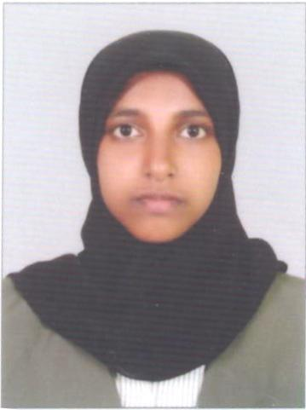
HASNA (LIBRARIAN)

Email: hasna.380870@2freemail.com

Personal Profile Statement
I have enjoyed a short time career in a library across the Calicut city which has led to considerable experience and expertise in librarianship. I am a dependable individual who always strives for perfection in everything I do, including the preserving and maintenance of valuable books.. I am also able to multi-manage several projects at once. Ultimately, I believe that my natural flair for customer service, along with my proficiency in handling both the technological and physical resources in libraries will make me a valuable employee for any library in the country.

Skills
- Excellent Communication and Interpersonal Skills
- The ability to be organized and methodical, something which is essential with the demands of everyday sorting and stacking in a library
- A naturally hospitable and friendly personality which is essential in community-oriented jobs
- Excellent computer literacy which is required in this newly electronic era of libraries(Library softwares )
- Highly familiar with the duties and responsibilities of a librarian due to previous experience, which means I only need limited guidance in my new role
- Excellent Customer-Service Skills

Work experience
2015 July-to present | School librarian | Markaz International School, Calicut

Main duties performed

  - Continually cataloguing, labeling and adding new books, CDs and DVDs to the library system—both physically and electronically
  - Sorting and stacking books on the correct shelves
  - Providing support and any resources needed for students
  - Guiding people on how to utilize the new electronic check-out machines in the library
  - Checking books out physically and stamping return dates
  - Assisting the visitors to the library with any enquiries they have, or if they can’t find a book
  - Maintaining general library cleanliness and orderliness
  - Jointly running the Summer Reading Challenge with another colleague

Education
2013 – 2015 |  | Master of library and information science | Farook College,Calicut | University of calicut
2010 – 2013 |  | BSc Physics | Dayapuram Arts and Science college for women,Calicut | University of Calicut
2008 – 2010 |  | Plus Two | REC Gov HSS | Kerala State Board
2010 |  | SSLC | Providence GHSS | Kerala State Board

Personal Details
DATE OF BIRTH : 15/08/1992
GENDER : FEMALE
AGE : 25
MARITAL STATUS : MARRIED
RELIGION : ISLAM
NATIONALITY : INDIAN

Achievements
- Post Graduated with a First class in library and information science
- Promoted within months to a school librarian at my locality.

Hobbies and interests
As with most librarians, my hobbies involve, first and foremost, reading books. I am also a novice writer of poetry and often participate in the group poetry readings in my local cafe every week. I also enjoy spending time with my family and friends on weekends.

