PROFILE SNAPSHOT
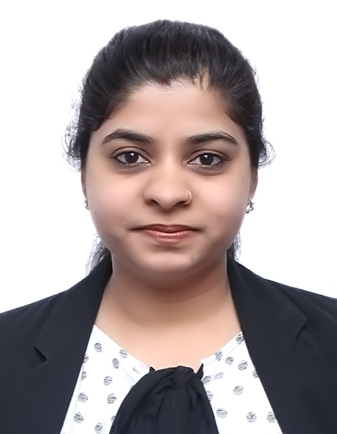

Email

Archana.380912@2freemail.com

Software proficiency

MS EXCEL

MS WORD

MS POWERPOINT

WINDOWS 10, 8, 7, XP

Programming Languages

MySQL

HTML, CSS, JavaScript

WordPress

NetBeans

C, C++, Core

PHP,

Core Java

Languages proficiency

English - Fluent

Hindi - Fluent

Urdu - Fluent

Punjabi - Fluent

I am a young, confident, enthusiastic, pro-active and assertive individual with almost 3 years of experience. Computer science graduate from TECHNOCRATS INSTITUTE OF TECHNOLOGY (EXCELLENCE), Bhopal, India. I have good computer skills (MS Office), excellent verbal and written communication skills.
Why me?
- 2 years of MIS, Sales &HRO experience
- 1 year of Inbound-outbound Tele Sales experience
- 6 months of Customer Service experience
- Excellent computer skills (MS Office)

TOTAL WORK EXPERIENCE – 3 years

Company: GCA CONSULTANCY | Location: Dubai
Designation: HR & Marketing Executive | Duration: March 2018 - Current
Key Responsibilities:

- Generating leads by finding vacancies across Dubai
- Conducting first round interviews of new candidates to filter out potential candidates
- KPI based on final placements of suitable candidates across all domains in Dubai
- Manpower consultant for skilled and non-skilled workforce
Company: HANU SOFTWARE SOLUTIONS (I) PVT. | Location: Delhi
Designation: Sales Associate & HRO | Duration: June 2016 - Oct 2017

Key Responsibilities:
- Data management and Data analysis on daily basis for US client and US Job Boards.  - Email handling, MIS Preparation and MIS Reporting.  - Quality Check on daily basis for processed live work.  - Preparation for daily task in excel sheet for live work for US client and US Job Boards.  - Handle daily/weekly/monthly performance report for team. | - Coordinate with sales team by managing schedules, filing important documents and communicating relevant information.  - Store and sort financial and non-financial data in electronic form and present reports.  - Handle the processing of all orders with accuracy and timeliness.
Company: XPREZTO INFO SOLUTIONS PVT.LTD |  | Location: Delhi
Designation: Sales Executive |  | Duration: April 2015- May 2016

Key Responsibilities:

- Voice Out-Bound Backend Process.
- Sold postpaid services and calling cards across US, Canada, Asia and African continent.
- Making a minimum 60-80 outgoing call lead provided by the company.
- Hit monthly target as per company requirement.
- Makin g calls and Report for the verification department
- Excellent knowledge of International Business Process Outsourcing for US and Canada Based Client's.
Key Responsibilities:
Company: IENERGIZER | Location: Noida
Designation: Customer Service Executive | Duration: Nov 2014 - April 2015
- Dish Tv new connection sales and Dish TV new device flex sales.
- Book international and domestic hotels and give resolution to customers.
- Provide customer service for Dish TV and GOIBIBO.

Achievements:
- Exceeded sales target by 300 per cent of Dell products and services with efficiency of 150 per cent in Average Handling Time(AHT)
- Exceeded customer satisfaction (CSAT) by 10 per cent

EDUCATION
Name of the Institute: TECHNOCRATS INSTITUTE OF TECHNOLOGY (EXCELLENCE), Bhopal, India | Duration (Full time): Aug 2010- May 2014
Graduation Degree: Bachelor of Engineering | Specialization: Computer Science Engineering
Projects Undertaken:

Project Title: ACTi Time Tool
Role: Test Engineer
Technology: PHP, MY SQL

Description:
Project was based on time tracking software. It tracked timing of tasks, tasks of each developers and a test engineer.
Responsibilities:
- Perform all process how task is assigned and developed, and test engineer track their work.
- Perform integration testing in each module how data is sent from one module to other module.
- Perform compatibility testing on it.
- Perform ad-hoc testing on it.

ADDITIONAL INFORMATION
Achievement:

- 3 Months Training of PHP & WordPress at “IT Brain Shapers” in New Delhi
- 3 Months Training of Manual Testing, SQL, Core Java & Selenium at “Qspider” in Noida.
- Programming Languages: C, C++, Core PHP, Core Java
- Database Software: MySQL
- Web Technology: HTML, CSS, JavaScript
- CMS: WordPress
- IDES: NetBeans

Personal Details

- Date of Birth: 15th January 1990
- Visa Type : Employment Visa
- Reference: Available on Request

