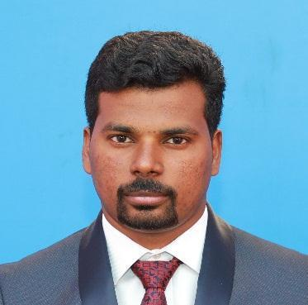CANDIDATEPROFILE

JOSEPH
IT SUPPORT ENGINEER,

joseph.380918@2freemail.com

PROFESSIONALOBJECTIVE:
Tohaveagoodcareerwithanorganizationofrepute,ledgeandskillstotheorganizationalsuccessandenhancemyexperiencesthroughcontinuouslearningandteamwork.

EXPERIENCES: • ITSUPPORTENGINEERatSDITECHCOMPUTERSERVICESLLC,DUBAI,UAE(JANUARY2015–DEC2017)

• SYSTEMADMINISTRATORatGATEWAYTECHNOLOGIESCHENNAI,INDIA(AUG2011TOJULY2014)

• DESKTOPENGINEERatBASELINETECHNOLOGIESCHENNAI,INDIA(FEB2010TOMARCH2011)

EDUCATIONPROFILE:

Course Stream University/Board Institution Year
B | achelor’sDegree | BachelorofartsEnglish |  | MaduraiKamarajerUniversity |  | MaduraiKamarajerUniversity-Madurai | 2011
HSSC |  | ComputerScience | GovernmentofTamilNadu |  |  | ST.Joseph’sHSSTHIRUTHUVAPURAM | 2006
SSLC |  |  | GovernmentofTamilNadu |  |  | ST.AloysusHSSMarthandanthurai | 2004

PROFESSIONALQUALIFICATION:

• MCSE(MicrosoftCertifiedSystemsEngineer)
• MCSA(MicrosoftCertifiedSystemsAdministrator)
• MCITPCommandITSolution,Thampanoor,Thiruvananthapuram,INDIA.•
• DiplomainComputerNetworkingEngineeringinGatewayTechnologies,Chennai,TamilNadu,INDIA.• DiplomainComputerHardware&EngineeringinSt.Xavier’sComputerCentre,TVM,INDIA

COCURRICULARACTIVITIES:

• Install,configure,andmaintainoperatingsystems,applicationsoftwareandsystemmanagementtools• Consultingclientsandcomputeruserstodeterminethenatureofproblems
• Investigating,diagnosingandsolvingcomputersoftwareandhardwarefaults• Agreeingtotimescales&Maintainingrecordsofsoftwarelicenses
• Configuring,installingandtroubleshootingMSoffice,Outlook,iPhone,Mac,Macmail.• Adding,removingorupdatinguseraccountinformation,resettingpassword,etc.
• ManagingPayroll,Time&attendanceandbackupapplications• ManagingBlackberrySmartphonesforemails
• PurchasingallITrelatedandotherelectronicsequipment’s• Troubleshootingsoftware,hardwareandnetworkingissues• Schedulingofservers,data,usersandemailbackup
• MonitoringandmanagingAntivirus
• Serveradministration,maintainuser,Group,OU,DNS,DHCP,etc.• maintainingconnectivitytotheinternetandVPNtoalloffice
• DubaiTradeE-services,FreightForwardingSoftware&allDubaitradingwebSitesknowledge.

CLIENT:VASCOGLOBALMARITIMELLC,GOODRICHMARITME,
CARAVELLOGISTICS,UTTAMGALVA,ECOPLAST,NIMAI,GreatWallInternational.Etc.

OTHERSOFTWARESKILLS

• MSoffice2003,2007,2010,2013,2016,Office365,adobePageMaker,Tallyetc.• TeamViewer,ammyadmin,AnyDesk.
• Completedatabackupsolution,Novabackupsolutionetc.

PERSONALDETAILS:

ADDRESS: FLAT810,BULDINGNO:19STREETNO9,ALHAMRIYAPOSTBOX:313
BURDUBAI,DUBAI,UAE.

DateofBirth : MaritalStatus:
04/03/1988
Marred

Languagesknown:English,Malayalam,Tamil,Hindi

IherebydeclarethattheinformationfurnishedaboveistruetothebestofmyknowledgeandIbeartheresponsibilityforcorrectnessoftheabovementionedparticulars.

