Vidya.381000@2freemail.com

VIDYA

BUSINESS DEVELOPMENT PROFESSIONAL

Bids preparation | Cost Estimation | Project Management

PROFESSIONAL SNAPSHOT:

Goal oriented Business Development Engineer with an experience of over 9 years across engineering and Business development activities such as Business Prospect Identification, Bid Preparation, Project & Contract Management, Client Relationship Management, QA/ HSE Operations, and Strategic Alliance Development across the Oil & Gas, Petrochemicals, and Refineries domain

- Skilled at analyzing potential and existing markets in order to identify business opportunities besides establishing customer base relations and its management data base

- Demonstrated abilities in conducting market research to develop strategies and roadmaps for bagging new projects and securing business relations

- Adept at technical writing for pre-qualifications and tender submissions, preparation of proposals, review of contract documents, assist Project Design teams, and develop value engineering solutions

- Deft at ensuring entire technical requirements of the client is fully conveyed to the team for their performance as per customer requirements, specifications, and relevant international codes

- Expertise in leading engineering design teams in coordinating, assigning, and supervising the work while identifying and resolving issues to perform efficient, effective and timely execution of engineering work

- Hands on experience in HMI software’s such as Intellution

IFIX 3.5, IFIX 4.0, RSview32, RS Logix 5000 and in designing P&ID drawings with software like Bentley Plant space P&ID, Bentley Microstation and in AutoCAD

- Possess sound planning, interpersonal skills, people management & coordination skills

Proposal Tendering
Management Operations

_{Project} Resource

Management ^{Planning &}
Management

Technical / | Scheduling &
Commercial
 | Planning
Negotiations

CAREER HIGHLIGHTS

Mott MacDonald & Company LLC, Muscat, Oman –2011- Jan 2017 Projects Managed
as Business Development Engineer Key Highlights:
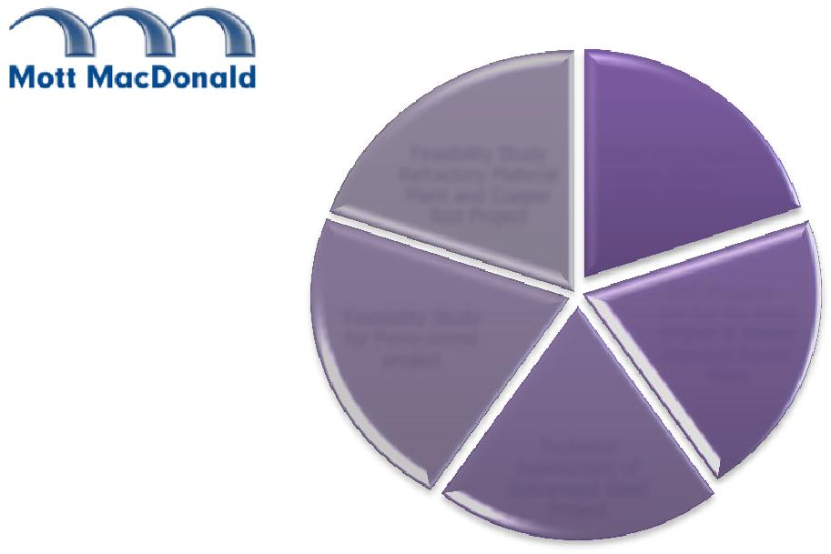
Business Development Operations

- Accountable for meeting new clients, maintaining relationships, preparing technical and commercial proposals for Engineering, understanding contract terms and making presentations, and submitting bids as a part of management during technical and commercial negotiations with client

- Coordinating with various Engineering disciplines, Quality Management, resource planning and scheduling

- Identifying new prospects in the Oman markets and outside countries and following up with them

Bidding & Proposals

- Reviewing enquires to decide on bid / no bid strategies and preparing technical and commercial bid proposals and tenders after thorough site visits during pre-bid stage and attending pre-bid meetings

Feasibility Study | Daleel Petroleum
Refractory Material | worth Million
Plant and Copper | Rials Omani
Rod Project
 | EPC Projects -
Feasibility Study | pre-bid for Amin
for Ferro-crome | Offplot & Rabab
project | Harweel Power
 | Plant

Technical
Assessment of
Galvanised Steel
Project

EDUCATIONAL QUALIFICATIONS

- B.E. – Instrumentation & Control Madras University, 2003

- PGDBA – Production & Operations Management

Symbiosis University, Pune, Pursuing

TECHNICAL SKILLS

- Cm C++, and Unix

- MS Office 2010, PIMS

- P&ID Drawing in Plant Space

- AutoCAD

- iFix 3.5 Version / iFix 4.0 Version – SCADA Software

PERSONAL DETAILS
- Date of Birth:

19th Dec 1981

- Languages Known: English, Tamil and Hindi

- Preparing Cost estimation, Risk analysis, and Project execution plans while coordinating Discipline Meetings for scope of work definition for proposals

- Proposing all types of bid submissions including pre-qualification and project tenders

- Developing time bound plans and scheduling the engineering activities along with preliminary Resource Planning and forecast for proposals

- Understanding the risk associated with the project and developing mitigation strategy

Project Management

- Conducting site visits and promoting continuous interaction with the execution team to manage complete execution of the projects

- Appointing third party consultant, reviewing reports while performing scheduling and cost management activities

- Initiating project progress meetings with the client and ensuring effective communication until project end

- Identifying clear scopes for various disciplines including process, civil, mechanical, C&A, Electrical, and Pipelines

- Conducting technical discussions and ensuring timely completion of the deliverables, submission of the deliverables and payment collection

- Adhering to QA/HSE compliances

Projects Bagged

- Successfully worked on bagging three major long term service contracts worth (10m Omani Rials)

- Demonstrated detailed on-time support and constant interaction with Oman Refineries and Petrochemicals Company to win an important Project management Service contract for Raysut Terminal Revamp Project and a repeat order from the client (worth more than 1.5M Rials)

- Executed pre-bid engineering services for Amin On-plot and Amin Off-plot water injection development project; successfully won the detailed engineering services for the same project (worth 0.7M Omani Rials)

- Bagged various projects from Daleel Petroleum in B- Block area in Oman worth 1 Million rials Omani and from EPC Contractors namely, L&T, AHE, GPS, ATE, OOMCO, Galfar, TESCO, Takamul and new investment companies, etc. and International clients like ABB SpA, Khudairi Group, worth more than 1.5M Rials

- Bagged some major EPC projects worth more than 0.5 M rials- Amin Offplot injection project and Rabab Harweel Power plant and Amal HRSG Project, Salalah International airport fuel farm, Barik to BVS 8 SOGL loop project, Samra thermal power station - Jordon, Ajeel gas compressor project - Iraq

- Successfully negotiated contractual clauses in favour of the organization in two major manpower supply contracts from OGC and ORPIC companies

- Pivotal role as a Project Manager for O&G projects and provided pre-bid Engineering services for Zauliyah Gas compression project, Lekhwair Combined Cycle power plant, Rabab Harweel Power Plant, and Amal HRSG 1C project

- Operated as a part of the Strategic team to establish a JV incorporated company to pursue large EPC business and as a part of the Management team to develop strategic alliance with KBR for the larger projects of PDO & BP’s Khazzan development project

CDM India Ltd., Chennai – 2004 to 2007
As Instrumentation Engineer

Key Result Areas:

- Worked on two projects -Southside Waste Water Treatment Plant and Tarrant Regional Water District

- Engaged in programming and designing graphics of human-machine interface (HMI) control screens besides creating database work including memory mapping I/O point for checking the various types of I/O’s Assisted in Instrument Index development, preparing I/O lists, and creating Loop Description and Tag Generation

- Focused on spotting and rectifying SCADA programming errors so as to increase efficiency and assisting in the development of Control System Architecture/ Network Architecture Design

- Provided technical support to the procurement team on equipment selection, developed Instrument data sheets and conducted trials to identify deviations and make relevant modifications to stabilise products

- Assisted the Management information systems (MIS) team in Collecting and summarizing the procurement of materials from various departments

