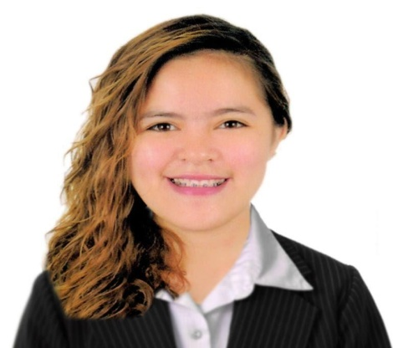
MARIELLE

Email Address: marielle.381003@2freemail.com

OBJECTIVES:

To work in an environment that provides opportunities with full determination and dedication to achieve organizational as well as personal goals.

WORK EXPERIENCE & TRAININGS:

Nov. 2014 – Dec. 2014 Unit 107 Heart of the City Condominium, Sgt. Esguerra Intern/Researcher Cor. Lopez Drive, South Triangle, Quezon City
Bayan Productions, Inc.
(Entertainment/Media)

- Helps in organizing, planning and researching everything that will happen during the program such as who’ll be interviewed, the location, etc.
- Responsible in keeping accurate records.
- Collects, verifies and prepares information for TV shoots.

May 2015 – March 2018 962 Aurora Blvd, Project 4, Quezon City, Email Support Representative 1109 Metro Manila
TaskUs, Inc. – UBER

- Attends to customer inquiries and complaints through email.
- Comprehends and addresses their concerns as quick as possible.

EDUCATIONAL BACKGROUND:

Bachelor of Broadcast in Communication June 2011 - April 2015
College of Communication
Polytechnic University of the Philippines
PERSONAL DATA:

DATE OF BIRTH : June 22, 1995
PLACE OF BIRTH : Quezon City, Manila
SEX : Female
CIVIL STATUS : Single
CITIZENSHIP : Filipino
WEIGHT : 112.2 lbs.
HEIGHT : 5’0”

