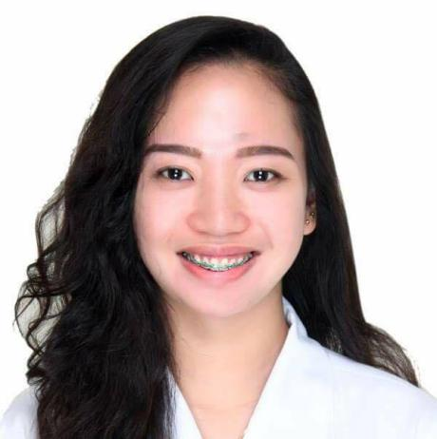

**Theresa**

Email Address: [Theresa.381019@2freemail.com](mailto:Theresa.381019@2freemail.com)

**WORK EXPERIENCE**

**Land Bank of the Philippines**

Quezon Lending Center

Brgy. Gulang-GulangLucena City, Philippines

On-the-Job Training

May 2016 – August 2016

**CAREER OBJECTIVE**

**To gain knowledge thru your institution and thru the use of my skills, know- how and education; to contribute towards developing and expanding business opportunities with the chance to advance in management role, combined with a desire to utilize my skill; moreover to be an effective and efficient employee in soon to be “our” company.**

* Receive and count cash at the beginning and at the closing of shifts
* Identify customers, validate, and cash checks
* Receive cash and checks for slip deposit
* Process cash and check withdrawals
* Perform specialized tasks like preparing checks, personal money orders and exchanging foreign currency
* Verify and receive loan and utility bill payments, as well as mortgage payments
* Record all transactions correctly and in compliance with bank guidelines
* Balance cash and check transactions at the closing of each shift
* Answer inquiries relating to current and savings accounts, as well as on other bank related products
* Open new accounts.

**EDUCATIONAL BACKGROUND**

**TERTIARY SCHOOL:**

Bachelor of Science in BusinessAdministration,

Major in Financial Management

Sacred Heart College

1Merchan St. Lucena City, Philippines

2013-2017

**AFFILIATIONS**

**Tan Law Firm**

Quezon Province

Philippines

Secretary

September 2016 - September 2017

* **College of Business Administration Student Council**

Treasurer, 2016- 2017

* **Cordian Cultural Dance Troupe**

Vice-President, 2014-2016

* **Junior Confederation of Finance Association – Philippines (JCFAP)**

Member, 2015- 2017

* **Junior Financial and Investment Executives (JFINEX)**

Member, 2015- 2017

* Answering calls, taking messages and handling correspondence
* Maintaining diaries and arranging appointments
* Typing, preparing and collating reports
* Filing
* Organising and servicing meetings (producing agendas and taking minutes)
* Managing databases
* Prioritising workloads
* Implementing new procedures and administrative systems
* Liaising with relevant organisations and clients
* Coordinating mail-shots and similar publicity tasks
* Logging or processing bills or expenses
* Acting as a receptionist and/or meeting and greeting clients

**PERSONAL INFORMATION**

**Date of Birth :** October 11, 1996

**Age** **:** 21 years old

**Religion :** Roman Catholic

**Weight :** 56 kg.

**Height :** 5’7 ft.

**Nationality :** Filipino

**Gender :** Female

**Civil Status :** Single

**Languages :** English, Filipino

**Place of Birth :** Lucena City

* SAP Business One (TB1000 Logistics)
* Sacred Heart College, Lucena City, Philippines October 2014
* SAP Business One (TB1100 Financials)
* Sacred Heart College-Lucena City,Philippines March 2015
* SAP Business One (Implementation and Support Module)
* Sacred Heart College, Lucena City,Philippines October 2015
* 1stQuezonian Business Summit
* Sacred Heart College, Lucena City,Philippines January 2015
* UST-JFINEX 5th National Finance Summit: Synergy Unbound
* University of Santo Tomas, Manila, PhilippinesDecember 2015
* JCFAP National Finance Summit
* SMX Convention Center, Pasay City,Philippines January 2016
* 2ndQuezonian Business Summit
* Sacred Heart College, Lucena City,PhilippinesJanuary 2016
* Student Leaders Financial Summit 2016
* SMX Convention Center, SM Aura Premier,Philippines April 2016
* National Finance Congress
* De La Salle University, Manila, PhilippinesAugust 2016
* Junior People Mgmt Assoc. of the Phil.: Learning Session
* Citystate Tower Ermita, Manila, PhilippinesAugust 2016
* Finance Literacy Caravan
* LPU Batangas, Batangas City,Philippines September 2016
* Investagrams Traders’ Summit
* Asian Institute of Management, Makati,Philippines October 2016
* International Finance Summit 2016
* De La Salle University, Manila,Philippines December 2016
* JCFAP National Finance Summit
* SMX Convention Center, Pasay City, PhilippinesJanuary 2017
* Strong sense of responsibility and self-motivation
* Knowledge in System Application Product (SAP)
* Proficient in Microsoft Office and other Computer Application
* Results-driven achiever with exemplary planning and organizational skills
* Resourceful team player who excels at building trusting relationships with customers and colleagues
* Willing to undergo training and upgrade skills
* Artistic
* Capable of multitasking

**SKILLS**

**SEMINARS AND TRAININGS ATTENDED**

* Collaborate with Private Banker to assist clients in accomplishing wealth management objectives.
* Develop and maintain professional understanding of customer base to assist Banker deepening current relationships.
* Perform as key contact for selected customer relationships under Banker guidance.
* Initiate apt activities to ensure on time and scheduled response to customers.
* Ensure to alert Banker with respect to any delays along with potential issues.
* Support to open and link new accounts on One Source.
* Provide assistance to Banker to attain approval on new account openings.
* Review independently all documents and link entire customer accounts to suitable relationship.
* Provide securities details, quotes and valuations to customers.
* Implement and supervise all unsolicited trade activities.
* Ensure to alert Banker of prospective sales opportunities surface from discussions with clients.
* Conduct evaluation of client’s accounts.
* Collect mandatory information to analyze client situation.
* Develop and oversee relationships with clients performing alongside Relationship Manager to ensure top level service provided to clients.
* Perform as key contact point for portfolio of clients dealing with routine matters throughout range of services and products.

**Dunia Finance LLC**

Muroor Branch, Abu Dhab9i UAE

Relationship Officer

November 2017- May 2018