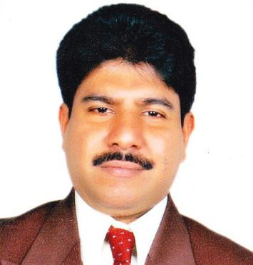

RESUME

______________________________________________________________________

Name

Thomas

Date of Birth

20.04.1966

Religion

Roman Catholic

Marital Status

Married

Email Thomas.381043@2freemail.com

______________________________________________________________________

Objective

At all times to be a successful delegate for the company by maintaining client relations and service levels and being responsive to needs.

Personal Appraisal

Strategic approach and a pro-active attitude highlight my strengths.

Organization Skills

MS Office

Education

Passed S.S.C

- 1984

Work Experience

 June 2010 - October 2015

Mantra Restaurant - U.S.A

Sr. Banquet Executive / Housekeeping

 May 1991 - February 2010

Maldives Inflight Catering Pte Ltd - Male

Catering Officer / Asst Supervisor

 April 1987 - December 1990

Ambassador Sky Chef Trainee Catering Officer

Achievements  Special merit for outstanding performance from Maldives Inflight Catering Pte Ltd - Male ( 1996 - 1998 )

- Compliment for outstanding performance from Condor Airlines - Lufthansa Airlines group ( 1997 )

Skills / Competencies

Leadership and Teamwork.

Energizing workplace and mobilizing resources.

Personal Attitudes

Engaging and involving team productive output.

High level of energy and effort intensity.

Concern and commitment to performance at high standard.

Perceived Strengths

Time management.

Good interpersonal skills.

Initiative.

Confident.

Good man-management skills.

Languages known

English, Konkani, Marathi and Hindi.

Hobbies

Football, Cricket, Table Tennis, Basket Ball.

Place Mumbai

