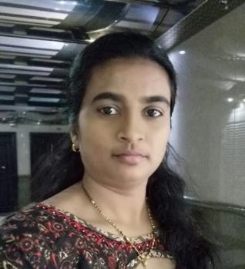
CHANDANA
EMAIL: chandana.381056@2freemail.com

Objective
To seek for a position in approval of your growing oriented company where I can utilize my skill. Acquire new ability to well with people.
PROFILE STATEMENT:

An energetic and hard-working individual with a strong desire to succeed. Detail- orientated and professional in both performance and presentation. Proven ability to plan and complete multiple tasks within strict deadlines, to learn new tasks quickly and to communicate effectively at all levels. A team player who is always willing to go the extra mile.

Academic Background
- M.Sc. in Biotechnology from Andhra University, Visakhapatnam- 2011
- B.Ed. in Biological Science from Andhra University, Visakhapatnam-2009
- B.Sc. in Biotechnology from Andhra University, Visakhapatnam-2007

Professional Experience
- For the last three years working front office receptionist Aditya hometel hotel in Hyderabad (Jan 2015 –Mar 2018).

- In 2010-2011 One-year project in Horticulture Research station kovvur. Tissue culture work on banana Plants.

- Worked as a councilor in Rajiv Aurogya Sri year Nov 2007 - 2009

Personality Traits & Computer Knowledge
  - Greet and welcome guest in person and on phone, answer and direct inqueries to designated department.
  - Maintain log books, front desk expenditures and calls received.
  - Responsible and great communication skills with the understanding of the medical terminology.
  - Very effective demonstration and leadership qualities.
  - Have computer skills such as word, outlook, excel, access etc.
  - Strong ability to adapt the new environment very soon.
  - Can handle queries very well with the nice interpersonal skills.
  - MS Word
  - Activities of Daily Living (ADL)
  - MS Power point
  - Well versed in basic use of computer & Internet savvy

skills
- Answering queries and recording relevant requirements from clients
- Following up clients after Property show and assisting necessary demands
- Organizing appointment for clients with regards to the Property checking
- handling confidential information, including rental applications and copies of personal identification documents
- Receiving and processing incoming and outgoing mail
- Arranging Orders of office supplies
- Arrange hotel booking, car rentals and flight reservation for the Executive Director & Managing Director and for the guest
- Arrange orders of Office Stationary Supplies for Head Office and Site office

Personal Details:
Dob : 16-01-1986
Gender : Female
Nationality : Indian
Linguistic skills: English, Hindi, Telugu

Page 2

