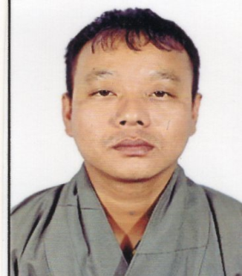
CURRICULUM VITAE (CV)

POSITION: SECURITY GUARD

OBJECTIVE

To find a platform where I can put my potentialities to enhance and accelerate my knowledge on management skills, program development, training experience and quality assurance as well.

SUMMARY

I have graduated from Phuentsholing Higher Secondary School. I have been actively participating in activities related to arm force an in addition I have experience in hotel management. I am a career oriented as well as hard working too.

PERSONAL DETAILS

Full name : Yeshey
Educational Qualification : Class X11
Nationality : Bhutanese
DOB : 16/10/1986
Marital Status : Single
Email : yeshey.381091@2freemail.com
Hobbies : socializing with people,reading books.
Language known : English, Dzongkha, Nepali, Hindi, Sharchop, Kurtoep
Height : 5.5ft

INTEREST
- To learn new things
- To learn other country’s language
- To make new friends

HIGHTLIGHT

- Focused and Disciplined
- Positive attitude
- Rapid Adaptability to new Environment
- Can work alone and with team comfortably

ACCOMPLISHMENTS

- Successfully completed in 2002
EXPERICENCE / ROLES & RESPONSIBILITIES

- Ten years experience in Arm Forces of Bhutan
- Hotel management
- Driving experience

ACADEMIC QUALIFICATION
Sl. No. | Institute /School Name | Country | Qualification | From | To
1 | Phuentsholing HSS | Bhutan | X11 | 2001 | 2002

TRAINING AND WORKSHOP ATTENDED
Sl. No. | Institute /School Name | Country | Qualification | Duration
1 | Jigmeling, Sarpang | Bhutan | Arm force | 24 months
2 | Hotel Ga Me Ga | Phuentsholing,bhutan | - Hotel Management

SKILLS
- Excellent interpersonal relationship with colleagues
- Listening and effective verbal communication skills

