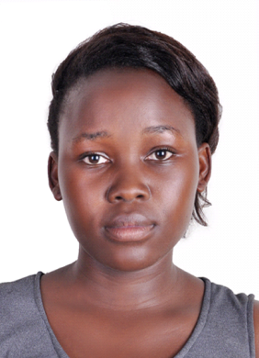
NAME : DEBORAH
NATIONALITY : UGANDAN
VISA STATUS : EMPLOYMENT
MARITAL STATUS: SINGLE
EMAIL ADDRESS : Deborah.381113@2freemail.com
DESIRED POSITION: Sales Associate
CAREER OBJECTIVE
A results-oriented individual with focus and a passion for providing excellent customer service I am also keen to find a challenging position with an exciting employer where I will be able to develop my career. I am ready to adapt to new skills and contribute to the achievement of the organizational goals.
PERSONAL SKILLS
- Highly motivated and enthusiastic
- Ability to stand for long hours, ability to lift and carry moderate amounts of weight.
- Ability to be flexible
- Customer service orientation
- Good communication skills, ability to read well and speak fluently in English language.
- Adaptability
WORK EXPERIENCE
- CARREFOUR SUPERMARKET ( AL GHURAIR MALL)
Designation: CASHIER
Year: APRIL, 2017 –CURRENT
- JOJOZ TAILORING AND FASHION CENTRE, UGANDA

Designation : SALES ASSOCIATE

Year : 2015-2017

RESPONSIBILITIES:

- Ensuring excellent customer service, product and discount knowledge

- Scanning items and ensuring proper price scanning

- Answering customers questions and providing information on procedures

- Carefully handling transactions, ensure customer receives correct change to avoid losses

- Providing customers with information about ongoing promotions in the store

- Welcoming customers, greeting them with an eye-to-eye contact

- Ensure high levels of customer satisfaction through excellent sales service

- Ensuring perfect display of the products

- Assess customers’ needs and provide assistance by giving product features

- Building productive trust relationships with customers

- Informing customers about latest products and shop promotions

CERTIFICATION

- Advanced Certificate of Education A level (U.A.C.E)

- Certificate of Education O level (U.C.E)

- Certificate in computer application
- Certificate in database administration

- Certificate of best cashier, November 2017
- Certificate of best cashier, February 2018
LANGUAGE PROFICIENCY
I am highly Excellent in English Language both verbal and written.
KEY COMPETETENCES
- Good communication skills
- Good public speaker.
- Highly organized
- Computer literate
DECLARATION
I DEBORAH declares that the above given information is true and correct to the best of my knowledge and belief describing my personal profile qualifications and experience correctly

