CURRICULAM VITAE
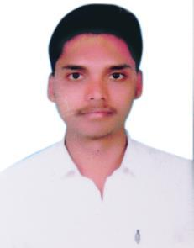

SRIKANTH
E-mail: srikanth.381140@2freemail.com

CAREER OBJECTIVE:

To grow with a leading organization that utilizes my abilities to the fullest extent possible, helping me realize and develop my potential and be a part of a team that scales great heights through continuous learning process and utmost dedication.

EDUCATIONAL QUALIFICATION:

Course Name | College Name | Year of passing | Percentage | Place
B.sc | Govt city college | 2016 | 65.10% | HYDERABAD
Intermediate | Narayana Jr. College | 2013 | 82.4% | HYDERABAD
SSC | SacredHeart Academy | 2011 | 73.8% | NIZAMABAD

ADDITIONAL SKILLS:

- Knowledge of TALLY ERP 9.0 and Microsoft applications.

- Excellent communication skills and ability to present complex information in an easy to understand format.

WORK EXPERIENCE:

- I have worked in HDB financial services which is on be half of HDFC BANK for 1 year i.e from 2016-2017.

- 2017-Worked as a Assistant accountant.Duties include:

  - professional bookkeeping
  - liaising with businesses
  - Data entry and retrieval

PERSONAL SKILLS:

- Ability to work in harmony with co-workers.

- Work minded and communicative.

- Ability to work under pressure.

- Time management

- Self- motivation.

ACHIEVEMENTS:

- Trained and certified in jawahar knowledge center (JKC) for Communication and Personality skills.

- Class representative during graduation from first year.

- Volunteered for several programes in college.

- Participated in many activities and won prizes for my excellence at school level.

PERSONAL DETAILS:

Date of Birth | : 14-12-1995
Gender | : | Male
Nationality | : | Indian
Languages Known | : English, Telugu and Hindi
Hobbies | : | Listening music and Reading novels

DECLARATION:

I here by declare that the information furnished above is true to the best of my knowledge and belief.

