SHIVA

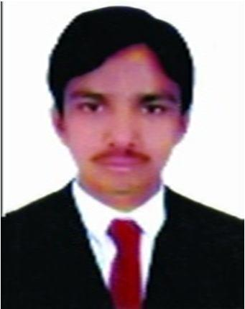

Email: Shiva.381158@2freemail.com

Driving License: 3 (UAE)

Nationality: India

Career Objective:

I am seeking employment with a company where i can use my talents and skills to grow and expand the company. I want a highly rewarding career where I can use my skills and knowledge to help the company and my co-workers is successful. I want to succeed in a stimulating and challenging environment, building the success of the company while I experience advancement opportunities.

Work Experiences:
Occupation or Position held: working as a vansales & driver at Hassani Trading Company.
(Dubai) since 23 Dec 2017 to till date.

Role: delivery driver and merchandiser for enoc,eppco and zoom market

Previous Work Experience:

Position held: worked as a driver in Blue King General Trading L.L.C Since feb 03-2016To nov 01-2017

Position Held: worked as a driver in valet parking.

Main activities and responsibilities:

Hard Experience in driving all Lmv vehicles

Responsible for the taking care of all kind of Automobiles.

Personal Skills:

A self-starter with a positive attitude,willingness to learn new concepts and accept
challenges.
Excellent communication skills and analyzing skills with a desire to learn and adapt to new
technologies and tools.

Technical Skills:
Computer Skill : MS Office Word, Excel, Power point, Internet Browsing & Emails

Operating System : Windows Xp,Win7,Win

Core Knowledge Areas:

Problem Recognition and Solution Development Exceptional Computer Skill Report Writing and Documentation

Having UAE LMV LICENCE:

(Issue date: 14/03/2015- Expire date: 14/03/2025)
Other Tasks:

Maintain inter-department communication and process overlaps.

Educational Status:
 |  |  |  | % of
Course | Subject | Institution/Board/University | Duration | Marks
Intermediate | Maths, | (Board of Intermediate Education | 2005-2007 | 76.1%
12th Grade | Physics, | TG,India)
 | Chemistry
Ssc | Mathematics | Narendra high school, armoor | 2004-2005 | 76.5%
10th Grade | and General | (Board of Secondary Education,)
 | Science
Personal Details:
 | Date of Birth | : | 09th may 1990
 | Languages | : | English, Hindi and Telugu
 | Nationality | : | Indian
 | Visa status | : | Employment

Declaration:

I hereby declare that the above mentioned information and particulars are true to the best of my knowledge and belief.

SHIVA

