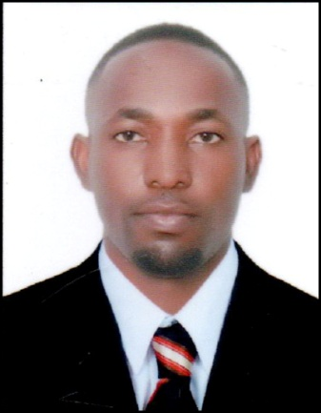
RESUME
Name : Daniel
Marital status : Married
Nationality : Ugandan
Languages : Fluent in English
Visa : Employment
Email : Daniel.381170@2freemail.com
JOB DESCRIPTION; SECURITY GUARD
OBJECTIVE:
An individual how can thrive in a fast paced environment, energetic, a good team player possessing the ability and confidence to contribute to the smooth running of the company.
Am looking for a suitable position that offers lots of opportunities for career development and better prospects
QUALIFICATIONS:
2008 – 2010 Diploma in microfinance from Kyambogo University (Certified)
2007 Department of Protective Systems (DPS)
2016 British Institute of Science and Cleaning (BISC)

KEYS AND COMPETENCES:
- Presentable with good communication skills
- High level of accuracy and attention to detail
- A team leader who easily adopt to the changing environment
- Energetic and good team player
- Able to work in fist paced environment
WORK EXPERIENCE AND RESPONSIBILITIES:
ADVANCE UGANDA MICRO FINANCE LTD.
From 2013 - 2015
Position: Credit Officer

Responsibility held:
- Clients screening and analyzing the purpose of the loan and willingness to pay back.
- Preparation of appraisal forms for the clients ready for loan disbursement.
- Collection of clients’ securities for the loan and ensuring proper safety.
- Disbursing loans to the approved clients and monitoring the loan repayment.
- Making report to the manager about the repayment performance.
- Organizing outreach programs in search for new clients to increase on the clientele base of the company.
ADVANCE UGANDA MICRO FINANCE LTD.
From 2011 - 2012
Position: Customer Service

Responsibility held:
- Account opening for the new clients in the bank.
Communicating the working system of the institution to the new clients.
- Helping clients with problems related the services provided in the institution.
- Providing detailed explanation on the new products developed for the clients by the institution.
- Receiving calls from customers for inquiry about their account information and related details
From 2016 to currently working with Farnek total facility management company (Dubai)
FARNEK SERVICES LLC
Position: Office boy / Receptionist (McCormick Kutas JFZA)

Responsibility held:
Stock and supply designated facility areas
Answering calls for inquiries and orders regarding the visitations to the company.
Providing customer care at the reception and other related duties.
Prepare the meeting room for the scheduled meetings, official files, materials to be used and beverages.
Maintaining all issues related to cleaning
AREAS OF EXPERTISE:
Basic Microsoft excel
Microsoft word
Microsoft outlook
HOBBIES:
Leaning new economic ideas
Playing volleyball
Watching foot ball

