ANDREY
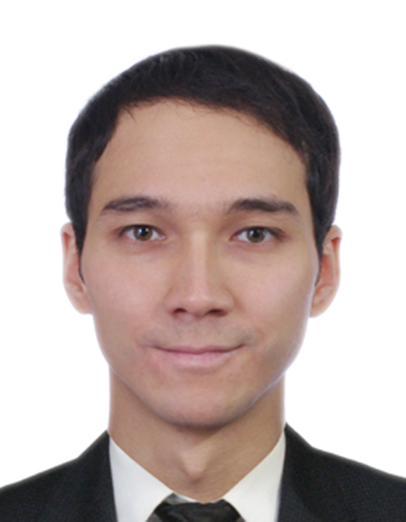

E-mail: andrey.381172@2freemail.com
Nationality: Kazakhstan
.Age: 28

PERSONAL PROFILE
I am a responsible and a strong-willed person with a great interest in professional development, I stand out for management skills, technical knowledge in cars and IT, business and logistics. I am very highly motivated, energetic and always have a positive attitude.I like to learn something new for myself, to develop and to work honestly and fairly.

ACHIEVEMENTS
- 2013 - present - started to service computers and laptops as a System administrator and working as Self-Employed
- 2012-2013 –set up my own business, and worked as an executive director in a store “Gifts and Souvenirs from China”
- 2007-2012 - worked in the company for the production of joinery “West-Stolyar” as a production supervisor

WORK EXPERIENCE
2013 – present  Position: self-employed system administrator,  IT support engineer | Duties:  - Working with all family of Windows  - Windows Server, Microsoft AD, domains  - Virtualization via VMware, Hyper-V  - Installing, configuring, and maintain desktops, laptops  - Configuring WAN, LAN, DNS, DHCP  - Backup and restore of data  - Installing and supporting telecommunication equipment (routers, switches)  - Installation and adjustment of video surveillance  - Replacement, assembling, search and purchase of computer components  - Remote support
2012 – 2013  Store “Gifts and Souvenirs from China”  Position: executive director | Duties:  - Searching for employees  - Store Advertising  - Logistics with China  - Tax accounting  - Sales  - Revision  - Work with complaints
2007 – 2012  Joinery production company “West-Stolyar”  Position: production  supervisor | Duties:  - Monitoring the production process  - Preparation the list of cuts by drawings  - Partially managed warehouse  - Management of more than 20 carpenters  - Responsible for the logistics  - Work with the clients  - Offering of the product services  - Monitoring the performance of woodworking machines
EDUCATION
2007 – 2012 | S. Amanzholov East Kazakhstan State University  the degree of Bachelor of Foreign Language: two foreign languages
CERTIFICATES
2018 | System Administrator Courses (Up-Grade education center of Kazakhstan)
SPECIAL SKILLS
Language proficiency | English - fluent  Russian - native
Computer skills | Microsoft Office, E-mail, Social Media, AutoCAD, Photoshop, CorelDraw
Hobbies | Power lifting, street workout, snowboarding, cars
Driving license | Yes, 10 years of experience (valid in UAE)
PERSONAL CHARACTERISTICS
- Responsible
- Honest
- Hardworking
- Quick-learning
- Punctual
- Multi-tasking

