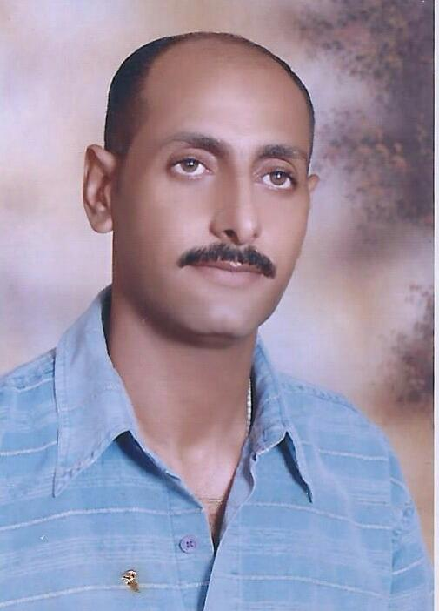
C.V
NAME: Osama
Place of birth: Alexandria. Egypt.
Email address: osama.381178@2freemail.com
Date of birth: 23/05/1973.
CAREER OBJECTIVE
To seek a challenging and exciting position in your esteemed organization ,where I can utilize my skills to make tangible contribution to growth.And to enhance my knowledge by working in a dynamic company that’s prides itself in giving substantial responsibilities to a new talent.
PROFILE SUMMRY
Flexibleemployee, self-motivated, dynamic, determined in achieving my goals, with outstanding work record and experience at those sectors Adminitrations,customer service,facility management’s ,Call center and front office. For more than (10) years..
KEYS AND PERSONAL SKILLS

- Administrative | - Welfare activities
- Desk jobs | - Data entry
- Scheduling | - Time managements
- Documentations | - Data entry 45wpm
- Problem solving | - Quick response
- Office coordinator | - Customer service
- Clients relation | - Negotiations
- Tele skills | - Social responsibility
- Hospitality | - Inventory controller
- Petty cash holder | - Acc. Knowledgments
- Bilingual ( Arabic&English)

WORKEXPERIENCE.

THE TITLE | COMPANY NAME | WHERE | FROM | TO
Representive | SKYLINE CO., FOR ADVERTISING | Egypt, Alexandria | 1993 | 1995
Facility Team leader | El daman gulf co., | Kuwait (p.o.w) | 1995 | 1999
Accountant assistant | ENTERCON FOR TRADING AND CONTRACTING | Egypt , Alexandria | 2000 | 2002
Data entry | EMS FOR COMPUTER SERVICES | Kuwait ( ministry of justice ) | 2002 | 2006
Customer service supervisor | Care service co., | Egypt. Alexandria | 2008 | 2011
Document controller | EMAAR  ( Turner for projects management) | Egypt. Alexandria | 2011 | 2014
Executive secretary | EL ANDALOS  Service  Turner for projects management) | Egypt. Alexandria | 2015 | 2016
Inventory controller  ( warehousing) | RABYA  For landscaping  (Turner International Middle East ) | Egypt. Alexandria | 2016 | 2018

EDUCATION & TRAINING
Bachelor of Commerce.
Accounting Department.
UNIVERSITY OF ALEXANDRIA.
Graduated at 1994
Grade :Good.

