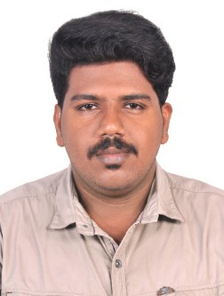
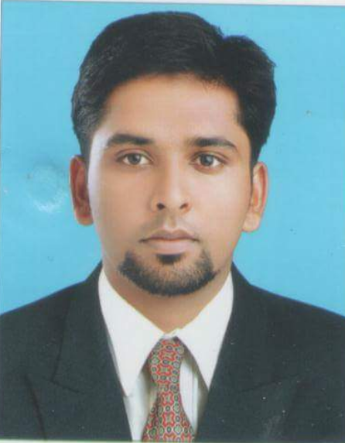

HAKKIM

E- MAIL:
Hakim.381253@2freemail.com

PERSONAL DATA
Dateof Birth :19/02/1991 Sex :Male
Nationality : Indian Marital Status : Married
Religion : Muslim
Visa status : Visiting Visa

LANGUAGES KNOWN
English Hindi
Malayalam Tamil
RESUME

OBJECTIVE
Seeking career advancement and professional alignment with a well reputed organizationin order to use my technical, managerial and personal skills to serve the company to its best of interest and to learn as much as possible in my field.

WORK EXPERIENCES
- IP BILLING & ACCOUNTS
Travancore Medical College
APRIL 2014 – MAY 2015

- LABOR CONTROL DEPARTMENT
United Cleaning Company, Qatar
MAY 2015 – MARCH 2018

DUTIES AND RESPONSIBILITIES
- IP BILLING AND ACCOUNTS
- Prepare monthly salary summary details
- Controlling cash float in the cash box
- Preparing cash reports daily
- Compiling all hospital reports daily, monthly, yearly.
- LABOR CONTROL DEPARTMENT
- Prepare and submitting all labors salary and other monthly benefits handed over o the accounts dept.
- Report to the Operations Manager on all operational and administrative needs of the staff of his/her area of responsibility
- Organizing manpower fittings for the new projects
- Preparing monthly cleaning reports
- Checking and confirming staff attendances by signing attendance sheets on daily basis
- Handling incident reports
- Preparing and maintaining staff records
- Prepare monthly total salary summary.
- Organizing staff replacements and swapping for operational requirements for different sites
- Check that the company assets are preserved and not misused.
ACADEMICCREDENTIALS
B.com with Computer Application
Fatima Matha National collegekollam
Passed out in June 2013
DIPLOMA In Mechanical Engineering
V Institute ITI Centre, Kollam
passed out in 2010 with 80%
HSE
MSM HSS,karicodeKollam- State Board Passed out in March 2008with 70%.
SSLC
MEA HSS, Kari code Kollam- State Board Passed out in March 2006with 80%.

SPECIALIZATION

- Confident about completing the work on time
- Flexible and Ability to Multitask.
- Bright Accounting & office software.
- Efficient in working with MS Office and Outlook Products (MS-Word, Excel and Power point and an avid Internet User.)
- Good in Written and Oral Communication in English
- Can effectively work both independently and as part of a team.

STRENGTHS
- Excellent oral and written communication skills.
- Project Planning & Mobilization Hard working
- Well-disciplined and punctual.
- Customer service skills.
- Fast learning skills.
- Good Team Worker
- Ability to adapt and learn at new technologies.

EXTRA CURRICULAR ACTIVITIES

- Active member in various sports teams in school and college levels.
- Winner of various competitions at school and collegelevel.
- Active member of Kerala Blood Donors Organization (KBDO)

TRAINING AND INDUSTRIAL VISITS

- Kerala Minerals And Metals Limited(KMML)
Chavara Kollam
- Arpal
Cleaning And Chemical Hygeine solutions
Doha,Qatar.

DECLARATION

I hereby declare that all the above furnished details are correctto the best of my knowledge.

