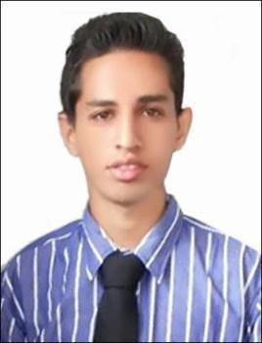

​​

Abdul Basit Bashir Parkar

Abdullah Al Zaroni Building, Room no. 202, near Al Futaim mosque,

Firiz Almurar Naif Road, Deira, Dubai

Tel: 00971551298859 |basitparkar61@gmail.com | 24 April 1994 |

Unmarried | Indian

Summary

2+ year experienced candidate as a pharmacist in retail. Knowledgeable and hardworking with interest to grow in the pharma market with a good organization.

Experience

October 2015 – March 2018

Retail Pharmacist

Hamdard Medical and General Stores.

- Managed a daily sale of 15000 INR.

- Dispensed medicines to patients with prescriptions from five HCPs.

- Daily bill updating including sales return and keeping accounts.

- Had excellent relationships with many customers.

- Handled the ordering of products from stockists.

- Excellent disease and drug knowledge.

Education

Qualified DHA 24 January 2018

GNCOP Sawarde B.Pharm(62.58% First Class)

- University Representative (2014)

- Sports Secretary (2013)

- Represented College at University for Cricket (2014/2015)

DBJ College Chiplun HSC (62.00% First Class)

- Captain of FYJC-Science Batch B Cricket Team (2010)

JMPS Fatima H Antule High School SSC (84.30% Silver Medalist)

Skills

Management​:Two+ years of planned approach to every individual patients, managed the store single-handedly on many occasions.

Product Knowledge​:Excellent knowledge of the products and always ready to tackle queries in relation to them. Undergone training for EHR(EPIC hyperspace), with a sound knowledge of US healthcare.

Fluen​t: English, Marathi, and Hindi.

Computer Knowledge​:Basic Excel, Internet along with the DAWA app for retail pharmacy. A quick learner.

●

●

●

●

●

●

●

●

●

​ ​

