CURRICULUM VITAE

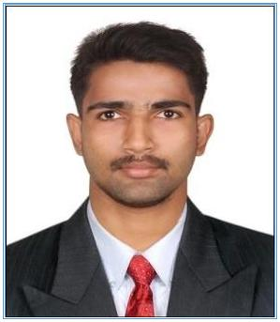

AKHIL

Email: akhil.381269@2freemail.com

OBJECTIVE

Seeking for challenging career by giving all my skills to my profession.

ACADEMIC QUALIFICATION
- M.A. Sociology, Lovely Professional University, Punjab, 2015

- B.A.Communicative English, Nirmala College, Muvattupuzha, 2013

- HIGHER SECONDARY EXAMINATION St. Mary’s Higher Secondary School, Arakuzha, 2010

- S.S.L.C St. Mary’s Higher Secondary School, Arakuzha, 2007

SYNOPSIS OF SKILL

- Well classroom management
- Excellent motivational, communication and written skills.
- Capacity to research and problem solving attitude.
- Ability to motivate students as well as guide them for better results.
- Good organizational skills and ability to arrange the sessions for students.
- Strong interpersonal and organizational skills.

PROFESSIONAL EXPERIENCE

- Teacher in English, R.M. Shah Public School Bijapur, Karnataka, India.

- Sales Executive in INUS MOTORS PVT. LTD. Kerala, India.

OTHER EXPERIENCE

- Worked as a Supervisor in Cochin Plywood Pvt. Ltd. Perumbavur, Kerala, India

COMPUTER QUALIFICATIONS

Operating System Office Productivity Tools

: Windows 98, Windows 2000, Windows XP, Windows

2007
: MS Word, MS Excel, Internet browsing and email

Page: 1-2

WORK/INTERNSHIP/VOLUNTARY WORK EXPERIENCE

NCC Cadet, NCC Nirmala College Muvattupuzha

Had undergone a good practical training as a part of NCC and earned in B certificate with B grade. (August 2010 – June 2011)

LANGUAGE PROFICIENCY

- English, Hindi and Malayalam ( Can Speak, Read and Writing)

PERSONAL DETAILS

Date of Birth | : 26-01-1990
Nationality | : Indian
Marital Status | : Single
Gender | : Male

KEY SKILLS AND COMPETENCIES

- Good Communication
- Confidence
- Leadership
- Hardworking
- Punctuality
- Initiative with a high level of energy

Declaration

I hereby declare that the information provided in my resume is true to the best my knowledge.

Page: 2-2

