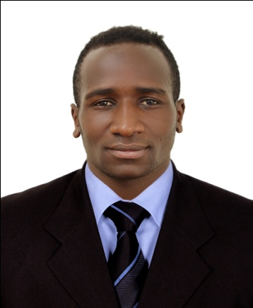
CURRICULUM VITAE
PERSONAL DETAILS
NAME : IBRAHIM
GENDER : Male
NATIONALITY : Kenyan
MARITAL STATUS : Single
LANGUAGES : English, Arabic and swahili
EMAIL : Ibrahim.381276@2freemail.com

CARRIER OBJECTIVE
To be prominent and work in an environment that demands interpersonal skills, confidence, hard work and be able to inspire and achieve optimal results through team work seeking a challenging and reward learning that empowers self development and organization creativity approach and decision making.

PERSONAL ATTRIBUTES
- Ready to learn new aspects and ideas
- Capable to work under minimal supervision
- Good communication skills
WORK EXPIRIENCE
MARCH 2017 TO DATE: ANSAR GROUP DUBAI - UAE
POSITION : sales man
DUTIES AND ROLES
- Receive payment by cash, check, credit cards, vouchers, or automatic debits.
- Issue receipts, refunds, credits, and change due to customers.
- Count money in cash drawers at the beginning of shifts to ensure that amounts are correct and that there is adequate change.
- Greet customers entering establishments.
- Maintain clean and orderly checkout areas.
- Establish or identify prices of goods, services or admission, and tabulate bills using optical price scanners.
- Issue trading stamps, and redeem food stamps and coupons.
- Resolve customer complaints.
- Calculate total payments received during a time period, and reconcile this with total sales.
- Compute and record totals of transactions.
- Keep periodic balance sheets of amounts and numbers of transactions.
2015 to 2016: TAIDIS RESTURANT - NAIROBI
POSITION : WAITER
DUTIES AND ROLES
• Provide the perfect service experience for every Guest
• Ensure the Guest feels important and welcome in the restaurant
• Ensure hot food is hot and cold food is cold
• Adhere to timing standards for products and services
• Look for ways to consolidate service and increase table turns
• Present menu, answer questions and make suggestions regarding food and beverage
• Serve the Guest in an accommodating manner
• must know all food liquor, beer, wine and retail offered
• Apply positive suggestive sales approach to guide Guest

EDUCATIONAL BACKGROUND
- DEC 2014 TO FEB 2015; BATEC COMPUTER COLLAGE
- Certificates in computer packages
- 2010– 2014; ; KAMELILO DAY HIGH SCHOOL[B -]
- Kenya certificates secondary education [KCSE]
2001-2009- ; KAMELILO PRIMARY
- Kenya certificates of primary education[KCPE]

APPLICABLE SKILLS
- Proficient in computer (ms/office, Word, Excel, Power Point)
- Good communication skills – English fluent
- Driving BCE license
HOBBIES AND INTRESTS
- Travelling
- Socializing
- Meeting new people
- Sports (Soccer)
- Reading

