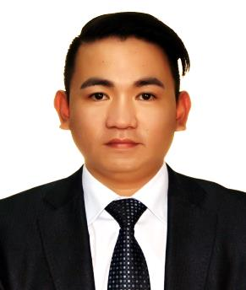
MICHAEL
Seek to work in an environment that will challenge me further; while allowing me to contribute to the continued growth and success of the organization. Obtain a position that will provide me the ability to apply my sales and work experience to a growing industry. Look forward to working with a company that promotes quality products and services, and provides me with the opportunity to meet and exceed assigned sales goals.

Email: Michael.381342@2freemail.com

SKILLS AND ATTRIBUTES

- With Bachelor’s Degree in Secondary Education Major in Mathematics
- 2 years’ experience in Teaching (Mathematics Teacher )
- 3 years’ experience in Sales Representative and Cashier ( Mobility and Office Automation Section )
- Knowledge in computer applications (Microsoft Word, Excel, PowerPoint) and Internet
- Can work with minimum supervision, team worker, dedicated, conscious on quality oriented job and with clear concept of professionalism.

WORK EXPERIENCE
Sales Representative(Mobility and Office Automation Section)
MAJID AL FUTTAIM RETAIL GROUP
February 2015 to May 2018
CARREFOUR HYPERMARKET Dubai, U.A.E

- Present, promote and sell product/services using solid arguments to existing and prospective customers.
- Achieve agreed upon sales targets and outcomes within schedules.
- Supply management with reports on customer needs, problems, interest, competitive activities, and potential for new product and services
- Resolves customer complaints by investigating the problems, developing solutions, preparing reports, making recommendations to the management.
- Suggest applicable and relevant up sells to help customer walk out to the door with everything they need.
- Sell specific products and services to customer and demonstrate products and show customer how to maximize their features.
- Discuss warranties and replacement parts.
- Remove security devices, clean the item, and place neatly in box.
- Check inventory to ensure product is in stock.

Mathematics Teacher (Secondary Level)
St. Joseph College Quezon City
June 2012 to June 2014
Center for Positive Futures, Philippines

- Teaches courses in mathematics to secondary pupils, following the course of study adopted by the Board of Education and appropriate curriculum publications as guidelines in teaching individual course content
- Utilizes an adopted course of study, instructional program guidelines, and other materials in planning and developing lesson plans and teaching outlines.
- Conducts teaching and instructional activities, using educational equipment, materials, books, and other learning aids.
- Maintain student records, including attendance records, immunization records, grades, and transfer information.

SEMINARS / TRAINING ATTENDED

- Microsoft Windows 10 Training  World Trade Center  Dubai U.A.E | - Nikon Camera Training  Carrefour Burjuman  Dubai U.A.E
- Samsung Appliances Training  Deira City Center  Dubai, U.A.E | - TP Link Router Training  Carrefour Burjuman  Dubai U.A.E

EDUCATION
Bachelor of Secondary Education
Major in mathematics
University of Rizal System
Rodriguez, Rizal Philippines
2008-2012

General Licerio Geronimo Memorial National High School
Rodriguez, Rizal Philippines
2002-2006

Geronimo Elementary School
Rodriguez, Rizal Philippines
1996-2002

PERSONAL DATA

Nationality- Filipino /Age- 28 / Birthday: July 27,1989
Height: 5’5 / Civil Status: Single / Language Spoken: English / Tagalog

