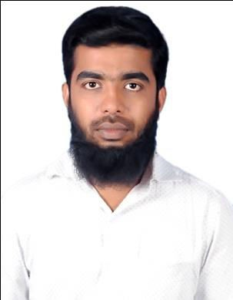

Aspiration:

ABDUL
abdul.381451@2freemail.com

A Dynamic young professional having 2 years experience in HR management, seeking a responsible and challenging career in a dynamic environment where can I explore my skills and work with the best of my ability for the benefit of the concern.

Professional summary:
Successful at helping new employees adjust to company and feel valued in their new
roles.

Employment History:
    - (March – 2014) to (April- 2016) Business Development Manager
Virtual working at Business Development Manager in A-care Facility Management and two year experience in HR field.

Job Description:

    - Customer satisfaction in Yamaha bike service and brand promotion.
    - Social media advertisement influencing purchase decision of buying branded product.
    - Participated in Best Manager Programs conducted by Jiffy Solutions.
    - SPSS, SAP (ABAP), HTML, MS-OFFICE.
    - Marketing strategy, Management information system.
    - Facility Management to provide best facility to make better customer satisfaction at Firm.

Educational Qualification:
    - MBA - (HR & Marketing) First Class, 2014 - Anna University, Chennai.
    - Bsc- (Computer Science) First Class, 2012- Barathidasan University of Jamal Mohamed College Trichy.

Job Description:
- System maintenance
- Servicing all kinds of Computers, laptops and its peripherals.
- Installation of software, OS and troubleshooting various installation issues.
- Advertisement and Sales Promotion
- Marketing Strategy and Market Research
- Entrepreneurship Development
- Brand Promotion
- Managerial behavior and Effectiveness

Personal Skills:
- Ability to effectively interact with members at all levels of the organization.
- Quickly adaptable to new technologies
- Flexible to different kinds of work environment
- Very good knowledge in Word, Excel, Outlook and PowerPoint presentation
- Basic accounting and expense management skills.
- Strong sense of responsibility and desire to get things done properly.

Technical Skills:
System : Hardware & Networking Operating systems : Windows XP, Windows 7/8/8.1 Recent Technologies : Brand promotion
Packages : Ms-Office (Excel, Word, PowerPoint)

Personal Information

Date of Birth : 27-06-1992
Gender : Male
Nationality : Indian
Marital Status : Single
Languages Known : Tamil & English.
Passport Number : P0242458

References
Available on request.

Declaration:

I hereby declare that the details furnished above are true and exact to the best of my knowledge.

