Murtuza  Embroidery Designer  Email: murtuza.381453@2freemail.com | 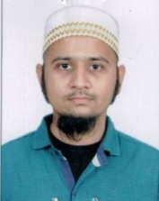

Key Skills
- Strong team player
- Excellent people management Skills
- Speed and accuracy of handling task independently
Working Experience
Previous jobs Raj Embroidery, India from 2005 to 2015
Sima Ahmed Tailoring & Embroidery, UAE from 2016 to 2018

Job handling
- Embroidery for Ladies Kandura / Abaya / Kurta / Dress etc.
- Creating new embroidery designs / Aplic patch work / Resham work / Zari work / Antique flowers / Padding patch / Dori work / Antique dori work (six / eight tar) Arabic designs like (Makhram / Alatul / Magribi ) / Zalabia / Morocco designs (African work)
- Belt termous
- Stitching ladies dress
Personal Details
- Date of Birth : 29th July’1988
- Marital Status : Married
- Nationality : Indian
- Religion : Islam
- Languages Known : English, Hindi, Urdu, Gujarati & basic Arabic
- Education qualification : SSC from KB Verra High School, Dombivali, Mumbai, India
- Visa Status : Visit visa valid till 31-July-2018

