CURRICULUM VITAE
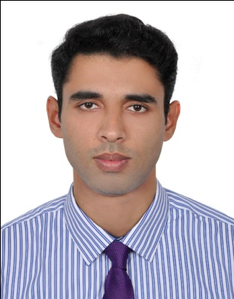
RAHIM

UNITED ARAB EMIRATES

rahim.381521@2freemail.com

Career Objective
- Intend to build a career with leading corporate with committed & dedicated people, which will help me to explore myself fully and realize my potential.
- To safeguard the interests of the public and keep an ethical standard within the trade.
- To establish myself as a successful professional by executing my skills acquired from my academic qualifications, rich experience by personal approach to a given problem. Application of my talents and skills in the new atmosphere, with challenging outlook to gain the desired result in a given field.

Academic Qualifications
Course Details | Name of the Institution | Board University | Year of Passing
Master Degree,  MBA | Calicut Institute Of Information Technology | Bharathiar University | (Pursuing)  2018
Bachelor  Degree,  BBA | Calicut Institute Of Information Technology | Bharathiar University | 2014
Diploma,  AIRLINE AND AIRPORT HANDLING MANAGEMENT | SpeedWings Aviation Academy Calicut | SpeedWings Aviation Academy Calicut | 2013
Diploma,  Computer Reservation System (Amadeus) | SpeedWings Aviation Academy Calicut | SpeedWings Aviation Academy Calicut | 2013
Diploma,  IATA  (UFTAA ) | SpeedWings Aviation Academy Calicut | University of Geneva Advanced Studies in Aviation Management | 2013
Diploma,  Airline Ticketing And Cargo Management | SpeedWings Aviation Academy Calicut | SpeedWings Aviation Academy Calicut | 2012
Diploma,  Computerized Financial Accounting | Accountants Service Society | Govt Of Kerala | 2012
XII Standard | Jdt Islam Higher Secondary School | Kerala State Board | 2009
X Standard | Malabar Christian College High School | Kerala State Board | 2007

Professional Experience

- Three Months experience as a customer service agent in Calicut International Airport, calicut, Kerala – INDIA (TRANNING)
- Three Months experience as a Ticketing Agent in Deira Travel & Tourist Agency, calicut, Kerala – INDIA (TRANNING)
- Two year experience as Check in Agent in Hajj Terminal At King Abdulaziz International Airport, Jeddah - SAUDI ARABIA (On Temporary Basis)
- Two year experience as a AIRLINE TICKETING STAFF /TOUR OPERATIOUR /ONLINE TRAVEL PORTAL HANDELING. At muscat ,OMAN (Metro Travel And Tourism)
Job Profile
- Dealing with customers
- Handling online clients
- Maintains customer records by updating account information.
- Handling face-to-face enquiries from customers
Vocational qualification
- Galileo
- Sabre Red
- Amadeus
- Office Package: MS Office
- Tally
- Platforms – Windows 2003 / XP / Vista
Area of interest
- Traveling
- Cooking

About Myself
- Capability to interact with others.
- Ability to deal with people diplomatically.
- Willingness to learn new things.
Language Proficiency
- Fluent in written and spoken English, Malayalam, Hindi. and knowledge of Urdu and Tamil.
Extracurricular Activities
- Drawing
- Swimming
- Football
- Cycling
- Social media
Personal Details
  - Date of Birth : 15th March 1991
  - Nationality : Indian
  - Place of Birth : Kerala (India)
  - Gender : male
  - Marital Status : Single

Problem Solving
Able to gather and analyze a wide range of complex information using logical reasoning & innovative solutions to problems.

Declaration
I hereby declare that above information is correct to the best of my knowledge and belief.

