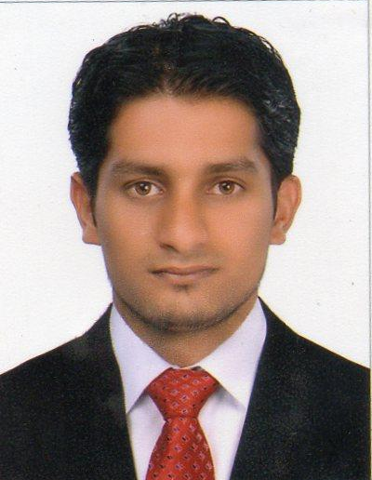
Haroon
E-mail: haroon.381524@2freemail.com
OBJECTIVE:
Seeking a long-term career in progressive and dynamic organization to utilize my knowledge and experience in a useful -and productive manner.
Profile:
- Good Communication skills with discipline, and hard working.
- Fast learner and dedicated in performing in duties and responsible with outstanding manners.
- Maintaining good merchandise display.
- Maintained the flow of the stocks for outgoing and incoming.
- Serving customer, cash handling responsibilities.
- Changing and checking the prices of each item.
- Keen to learn new skills and willing, to work long hours, as required.
- Takes pride in providing a high level of service
PROFESSIONALEXPERIENCE:
Viva International FZE (Dubai)
Job Description: Sales executive 2013-2016
- Identify business opportunities and target markets
- Promote different brands mobile given by manager and achieve the sales target
- Make initial customer contact through visits or calls
- Identify each potential customer’s needs
- Build meaningful relationships within the company and outside
- Ensure appropriate and timely delivery of service and products
- Follow up on service and / or product once the delivery has been made
- Arrange meetings with potential clients
- Challenge objections in order to get the customer to buy a product
- Check quantity and quality of mobiles to delivery
- Review self-sales performance with a view to improve it
- Search daily at the market price on the models of mobile phones that request it
- Communicate with customers and taking orders for models required
- Communication with suppliers to take the best deals in the market
- Offers daily available stock in the company with prices
- I always try to give customers the best offers.
G.R Constructions Pvt. Ltd, Mangalore Karnataka.
- Position: Safety officer - Safety Department (2012 – 2013)
Fashion Market, Mangalore Karnataka.
- Position: Sales
Educational Qualification
- SSLC. From Karnataka Secondary Education Board , Bangalore – Karnataka, India
- PUC From Karnataka university education board, Karnataka, India
- Diploma in Fire & Safety from NIFE, Mangalore, Karnataka
Computer Knowledge
- M.S Office (Word, Excel, & Power point)
Personal Details
Date of Birth | : | 14-02-1990
Marital Status | : | Single
Nationality | : | Indian
Languages Know | : | English, Hindi & Malayalam

