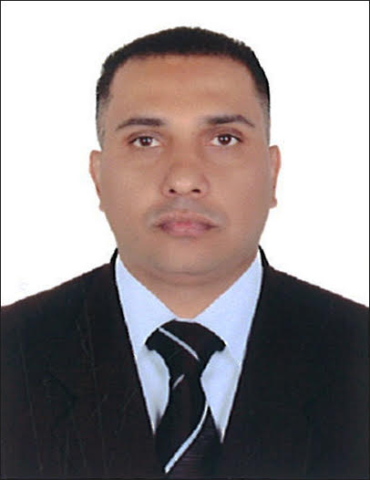
Curriculum Vitae
ATIF
Dubai, U.A.E
E-mail: atif.381549@2freemail.com
Address: Al Satwa Dubai-UAE

aPPLICATION FOR THE POST OF:driver

objective
Seeking for substantial responsibility where my past and varied experience would be fully utilized in a career opportunity and where making a significant contribution to the success of my employer which will gain me a career advancement opportunity.
Highlights
- Punctual and reliable Time management skills
- Courteous and polite demeanor Over the road experience
- Dependable and reliable Responsible driver
- Excellent sense of direction Defensive driver training
- Comfortable with overnight runs Local routes understanding
work experience
- Working as a Home Delivery Driver at BBQ Box Restaurant Dubai, UAE , from March 2018 To Till Date.
- Worked as a Driver at Enova Facilities Management Services LLC Dubai, from 2016 to Dec 2017.
- Worked as a Driver at Bloom Properties Abu Dhabi from May 2013 to Sep 2015.
- Worked as a HAVC Technician at Geco Mechanical & Electrical LTD Dubai from Jun 2008 to Apr 2012
Duties & Responsibilities
- Completed a daily pre-trip inspection checklist before first delivery of the day.
- Selected the most efficient routes in compliance with delivery instructions and fuel policy.
- Changed tires and installed light bulbs, fuses and tire chains.
- Presented customers with bills and receipts and collected payments for goods delivered.
- Checked vehicle's fluid levels and tire pressure and scheduled any required repairs.
- Established long-term customer relationships through prompt and courteous service.
- Resolved customer complaints and adjusted orders.

- Operated motor vehicles in a safe and efficient manner.
- Processed payments by accepting cash, checks and credit card payments.
- Processed payments by accepting cash, checks and credit card payments.
- Verified loads against shipping papers.
- Met and surpassed productivity targets and quality standards.
- Notified branch management of any vehicle safety concerns and issues.
- Obtained signatures needed to complete and process all paperwork in a timely manner.
- Answered customer questions regarding shipments.
- Handled merchandise in accordance with product handling standards.
- Verified sales orders before loading and unloading merchandise.
- Reported any errors found on delivery documents to supervisor.
- Evaluated customer needs and determined appropriate action, referring their questions to management when necessary.
- Inspected and maintained gas, oil and water levels as well as tires, lights and brakes.

key skills
- Well Experience above mentioned field
- Self Confident sincerity Hard Work and Punctuality
- Honest and dedicated Person
- Good Learning & Listening Abilities
- Committed to providing excellent quality service.
- Learn quickly, and able to work under pressure
EDUCATIONAL QUALIFICATION

- Matriculation from Pakistan
- Diploma in AC Technician
passport details
Date of issue : 15-02-2013
Date of expiry : 14-02-2023
Place of issue : Pakistan

Personal Details
Date of Birth : 11-11-1983
Nationality : Pakistani
Religion : Islam
Gender : Male
Marital Status : Single
Language Known : English, Urdu
Visa Status : Employment
Driving License Details
License Type : Light Vehicle (manual)
Date of Issue : 10-04-2013
Date of Expiry : 10-04-2023
Place of Issue : Dubai, UAE
Character References

- Available Upon Request
declaration

- I certify that all the details provided above are all correct according to my knowledge and belief.

