CURRICULUM VITAE
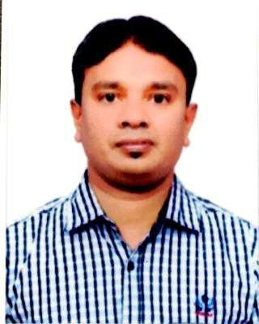

NOOR

E-mail: noor.381560@2freemail.com

OBJECTIVE | 1.Indoor sales, 2.Cashier 3.Counter supervisor.
 | To become a part of a dynamic group where I could further
 | explore the skills and capabilities,which I gained in the
 | whole working career and in present job experience, and to
 | serve in a challenging work environment with equally vast
 | opportunities of career development based upon
 | achievement results.

EWORK EXPERIENCERIENCE

Sana Fashion Trading LLC
January 2001 — December 2005

INDOOR SALES

Cloth Item Sales Section. Goods checking
Goods arranging. Stock checking.

1

Sana Fashion Trading LLC

January 2006 — June 2010

CASHIER

Receiving payment from customer. Smart payment

Handle all the customer

Refund problem salve and cash back with permission(supervisor).

Sana Fashion Trading LLC

January 2011 — December 2016

COUNTER SUPERVISOR

Cash Counter Checking.

Following the Counter Cashier. Following Goods Packer.
Any one Customer problem salve. Sales amount checking.

NMC Communications

January 2017 — January 2018

SALES

Indoor Sales.

Items Collecting and Checking. Payment Checking.
Customer Service.

EPROFESSIONAL SKILLSRIENCE

Good public relation skills and well liked by superiors.

Acquainting to the environment and grasping the things faster.

Young and Energetic and hardworking.

Perseverance fast learning ability, good communication and analytical.

A team worker and can handle work pressure with ease.

Ability and experienced to work in a team of multi lingual and multi nationality.

2

EDRIVING LICENCE DETAILSRIENCE

India Driving Licence - Manual

 | EDUCATION |  |  |  | Secondary School Certificate
 |  |  |  |  | January 1996 — March 1998
 |  |  |  |  | Government School Tamil Nadu India.
 |  |  |  |  | Institute of Electronics-Decibel Certificate
 |  |  |  |  | Diploma in GSM Chip Level Technology
 | LANGUAGE KNOWN
 |  |  |  |  | English,Hindi,Arabic,Tamil,Malayalam.
PERSONAL PROFILE
Date of birth |  | : 16-05-1974
Marital status |  | : Married
Nationality |  | : Indian
Religion |  | : Muslim
 |  |  |  |  | I hereby declare that above statements are true and best of my
 | DECLARATION
knowledge and belief.

NOOR

3

