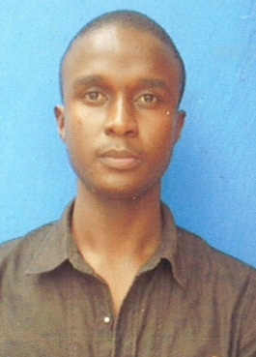
CURRICULUM VITA
PERSONAL DETAILS:
Name : NICHOLAS
Date of birth : 19-Sep-1993
Sex : Male
Martial status: Married
Nationality : Kenyan
Email : Nicholas.381573@2freemail.com
Visa status : visit visa 3 months
POFESSIONAL BACKGROUND:
Education:
2015-2016 nairobi aviation college pursued tour guiding management
2013-2014 radium security company (Qualified Profesional)
2012 Serema hotel certificate of participation
2009-2012 Kiburu secondary school certificate of secondary education.
2001-2008 kiangai primary school certificate of primary education.

POFESSIONAL QUALIFICATION:
- Computer literate all packages
- Enviromental certificate
- Professional security duties
- Diploma in tour guiding managememt
- Worked at Bonds garden restaurant as cashier and Assistant.
PERSONAL COMPETENCIES
Physically fit and mentally resilient professional who has the ability to maintain a sense of clain and control in difficult situations. Nicholas can acess a situation quickely then use appropriate actions of diffuse any tensions and resolve any misunderstanding that may rise. He always has a smart presentable appearance is customer focused and posseses a never ending commitment and adding value to anything that he does during his long career. He has regularly interacted with police officers, interviewed witnesses and even testified in court.Right now he is looking for a suitable position with a company that offers and attractive compensation package including compatable wages, flexible schedules and opertunities for advancement.
EMPLOYMENT HISTORY
OAK Place Hotel:
Worked as security Guard and duties were
- Investigation and following up all incidents that compromise safety and security.
- Greeting and providing general information to visitors and staff
- Maintaining alertiness to potential losses by theft and destruction.
- Observing departing personal to protect against theft of company property
- Enforcing the regulations pertaining to the parking of vehicles.
- Remaining alert for the presense of unauthorized persons.
AREAS OF EXPERTISE
- Patrolling premises
- Surveliance cameras
- Personal protection
- Securing premises
- Negotiating
- Restraining traspassers
- Calming people down
- Resolving conflict
- Interviewing witnesses
SECURITY SKILLS
- Dealing with transpassing and demonstrations
- Ability to act and take constrctive steps to solve an issue
- Can work , go up stairs and stand for long period of time
- Answering phone calls in a continuous and professional manner
- Highly numerable Literate and accurate.

HOBBIES
- Travelling
- Socializing
- Football
- Reading
LANGUAGES
- English
- Kiswahili
- Spanish

