OMAIR  Personal Information:  Marital Status: Married  Email: omair.381585@2freemail.com  Current Status: Visit Visa | 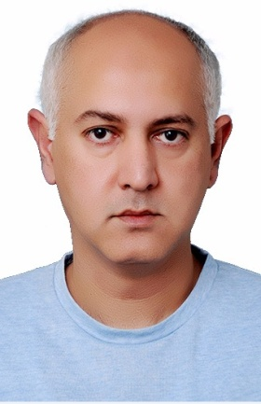

INTENT/ PROFICIENT OUTLINE

Suitable position with a progressive organization that offer potential for growth where my skills can be fully utilized, while making a significant contribution to the success of employer.

Key Skills: | Good communication and customer service skills, ability to multitask, and strong problem solving skills.
Education:  Language: | Master in Business Administration - Supply Chain Management (2010-2012)  Sarhad University – Islamabad, Pakistan.  English and Urdu / Hindi

PRACTICLE EXPERIENCE

Companies: | Designations: | Durations:
KlassicValley (Mineral Water)  Islamabad – Pakistan  Eva Cooking Oil &  Maan Ghee (Pvt) Ltd  Islamabad - Pakistan  MCB Bank (Pvt) Ltd.  (MCB – Consumer Asset Division) | Sales Manager  Sales/Customer Service Officer  Collection Officer | Feb 2008 – April 2018  Jan 2005 – Dec 2007  June 2000 – Dec 2004

Job Description:

Sales & Customer Service Experience

- Handling Sales and all frontend / backend correspondence with Customers.
- Responsible for stock transfer to Inventory on daily basis.
- Managing merchandizing of stocks
- Maintaining purchase order.
- Maintaining GRN’s (Good received note).
- Maintaining SDN.
- Project Purchase orders.
- Maintaining rate fluctuation in the Market, setting a new comparative rate on daily basis.
- Achieving the goals/Targets assigned by company in a term time.
- Collection of payment from retailors.
- Maintaining of sales and collection of products.
- Define / Achieve sales targets with the team.

Banking Experience:

- Verification of Clients/Company in Leasing Department.
- Recovery of Auto/Property/Business Loans, Front End Loans.
- Re-possession of Bank Assets from Clients.
- BTF (Balance transfer Facility)
- Credit Cards division.
- Achieving sales targets on monthly basis.

