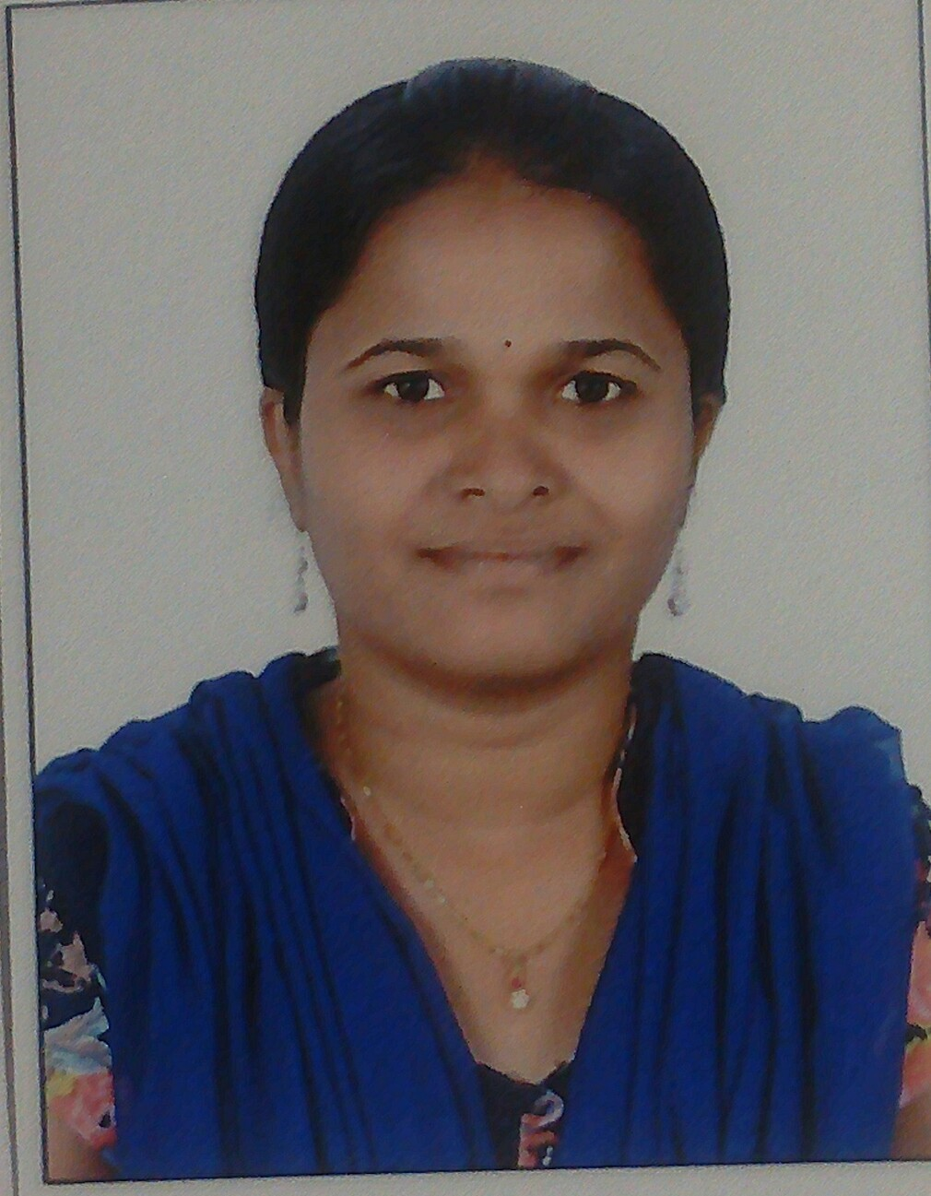Name: Vineetha

Vineetha.381604@2freemail.com

CAREEROBJECTIVE
To further my professional career with an executive level management position in a world class company. Seek to diversify my skills in another industry and as part of a larger organization. Relocation desirable
ACADEMICDETAILS
- B.Tech (ECE) [2016] with aggregate of 60% from Balaji institute of engineering & science
- Inter [2012] with aggregate of 65% from Sri vikas junior college
WORKEXPERIENCE
- Worked as Business development officer in Gleam global pvt.ltd from May 2016 to May 2017 Role :customer service

- Worked as Hr assistant in Swiggypvt .ltd from May 2017 to Nov 2017 Role :assistant

PROJECTDETAILS
  - Low-area and High throughtput Architecture For an Adaptive Using DistributedArithematic
Description : A high performance implemention for least mean square and adaptive filter is presented.the total architecture based on distributed arithmetic and we are using look up tables because LUTs are recalculated the partial products. we are using very less chip area and high throughput
Duration : 4months
Role : Team member

Team Size : 5
A Step size Control method for Deficient Length FBLMS algorithm
Description : In this project we are given to the input in time domain and using FBLMS to convertedinto frequency domain.we are using reverse FBLMS.Because in this process we convert to time to frequency domain and frequency to time domain.In this project we are using IEEE xplore
Duration : 4mnot@hs
Role : Team members

Team Size : 5
Low - area and High throughput Architecture for an Adaptive filter Using Distributed Arithmetic with feedback
Description : Adaptive filter using in many signal applications this total architecture based upon thedistributed arithmeticwe are using very less chip area and operate the high throughput and using look up tables in this project we are using IEEE explore we are taken to the project feedback
Duration : 4months
Role : Team members

Team Size : 5

FIELD OFINTERESTS
- Any office field
SKILLS
- Computer skills:Msoffice,VLSI,C-Language,xlinix
- Technical skills:Attendedtraining&placements sections
INDUSTRIALEXPOSURE

Inplant Trainingat:
- 2months Trained in Devaki technologies pvt.ltd
ACHIVEMENTS
- Participated power point presention in samishka

- Attended the PCB,DSP,ARM7workshops
CURRICULARACTIVITIES
- Playing carrom in my school level
- Palyingshettle in my school level
- Playing cricket in my college
STRENGTH &HOBBIES
- Self - confidence , self - disciplined and hard working
- Co - operative and adjustable nature
- Strongly self- motivated
- Willing to learn new things
- Playing shettle, reading new stories, watching cartoons
PERSONAL INFORMATION
Date of birth:04-08-1994
Nationality:Indian
Visa status:Visit visa

DECLARATION
I hereby declare that the above - mentioned information is correct up to my knowledge and I bear the responsibility for the correctness of the above - mentioned particulars.

