Curriculum Vitae

POSITION: ACCOUNTANT ASSISTANT / ADMIN CO-ORDINATOR
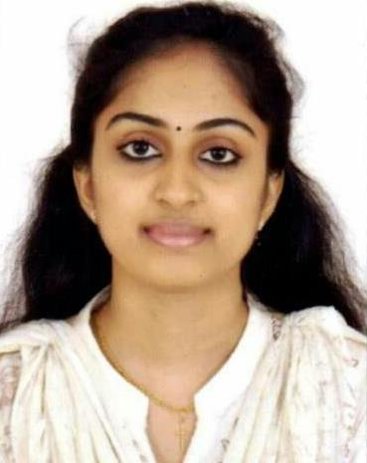

Josia (MBA in Finance & HR)
Dubai, UAE.

E-Mail: josia.381633@2freemail.com

 |  |  | To get a suitable placement and rewarding career in your company which
 | Career Objective
 |  |  | commensurate the Managerial and work experience set possessed.
 | Educational |  | Masters in Business Administration ( under Bharathiar University in 2017)
 | Qualifications:
 |  |  | Bachelor of Commerce (under Kerala University in 2015)
 | Additional |  | Diploma in Computer Application in 2015, MS Office.
 | Qualification:
 |  |  | A Study on quality of work life of employees with special reference to Kerala
 | Project:
 |  |  | Roadways Pvt.Ltd, in Kollam, Kerala
 | Internship: |  | TATA Chemicals Ltd., Coimbatore, Tamilnadu

1

TOTAL EXPERIENCE – 9 MONTHS IN INDIA

September 2017 – June 2018

Aabasoft Technologies, India Private Limited, Infopark, Kochi, Kerala.

The company is a global End to End IT/ITES services and solutions provider. We help our customers to do business better with our industry wide experience, deep technology ex[pertise and comprehensive portfolio of services.

Job Title : Process Associate.

Pitching products/services.

Maintaining fruitful relationships with existing customers.

Maintaining the CRM database.

Interact with customers through calls concerning various care issues.

Provide hands-on support of customer care initiatives.

Personal Details:
 | Date of Birth |  | : | 19/05/1994
 | Gender |  | : | Female
 | Nationality |  | : | Indian
 | Marital Status |  | : | Single
 | Visa Status |  | : | Visit Visa (Valid up to 8th September 2018)
 | Languages known |  | : | English, Hindi, Malayalam
 | Total Experience |  | : | 9 Months in India.
 | Hobbies |  | : | Travelling, Visited to Malaysia.
 | Achievements |  | : | Got “The Best Manager” Title conducted in
 |  |  |  | SVP College, Coimbatore
 |  |  | : | Received appreciated for “The Best HR Team”
 |  |  |  | Conducted in Nehru College, Pallakkad

2

