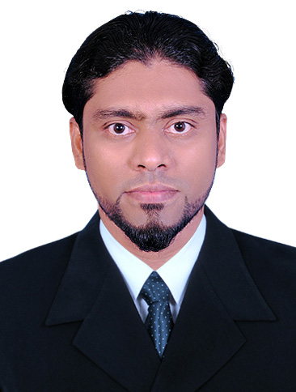 Ashraf
Ashraf.381642@2freemail.com

BIM SPECIALIST/ SR. ARCHITETURAL DRAUGHTSMAN
OBJECTIVE
I am interested in BIM specialist/Sr. Architectural Draughtsman position, wherein more than 10 years of extensive GCC experience in various fields of BIM, Architectural, Structural and 3D modeling will be fully utilized with using AutoCAD and Revit Architecture. My desire is to utilize acquired exposure for the growth and benefit of the firm.

areas of expertise
- BIM modelling by using Revit Architecture
- Architectural and structural drawings for Authority approval.
- Proposal architectural drawings as per client’s requirements and Authority regulations.
- 3D views of projects by using Auto CAD, Revit and 3D Studio Max.
- Preparation of shop drawings and details for Construction.
- Preparation of as built drawing for completion certificate.
- Preparation of structural detail shop drawings for construction.
- Preparation of Shop drawings, Marble Cutting list and Quantity taking.

proffessional experiences
In U.A.E- (10 years), Qatar (1 year)

I worked as a BIM Specialist in Qatar Consol Doha, Qatar
From March 2017 to February 2018.
- Preparation of Building 3D geometries for Qatar Metro Major stations by using Revit
- Extraction from Revit to 2D cad for developing shop drawings
- Preparation of Shop drawings and details by Using Revit and CAD
- Quantity taking for various Metro Stations.
- Coordination with all related design fields to resolve clashes and queries

Worked as Sr. Architectural draughtsman cum BIM designer in Mosart Marble & Mosaic Intl. SAL. Abudhabi, Uae
From June 2013 to February 2017.

PROJECT.
- Midfield Terminal Project Abudhabi.
- Presidential palace project Abudhabi.

duties & responsibilities
- Preparation of shop drawings for piers of Airport with actual coordinates, and making blow up details.
- Preparation of 3D floor with all coordination by using Revit architecture for Airport project
- Preparation of shop drawings as per contract drawings and material schedule for submission to consultant approval for Palace project.
- Preparation of technical details, section and blow up for the interior and exterior marble work.
- Quantity taking and produce Cutting List of marble to be cut for the marble installation.

Worked as a Senior Architectural draughtsman in M/s SAM Building Contracting LLC. Dubai, from April 2007 to December 2012.

PROJECTS.
- Warehouse and Office Buildings (BF2+Bf1+GF+FF ) - M/s Naser Al Sayer at JAFZA, UAE
- Factory and offices for L&T Electrical and Automation FZE. at JAFZA, UAE
- Labor Accommodation(G+4) - M/s Khalifa Mattar Saeed Al Mazeena, Al-Ghusais, UAE
- Factory, Warehouse and (G+4) Office Bldg. for M/s United Marketing Group at JAFZA.
- Factory and G+1 Office Building – M/s Caparol Techno Park, UAE
- Bandag factory, First stop, Training centre, for Bridgestone, at JAFZA, UAE

In India- (more than 6 years)
- 4 years worked as a Senior AutoCAD draughtsman in M/s Major Building experts and consulting engineers in Kerala, India from October 2003 to February 2007
- 2 years worked as an AutoCAD draughtsman in M/s Dream House constructions, Kerala, India from August 2000 to October 2003

duties & responsibilities
- Develop the basic concept of the building and prepare the drawings as per Authority rules & regulation
- Responsible for the development of details, technical drawings.
- Designing Residential buildings and its 3D view preparation
- Reviews plans to determine what information must be incorporated into the new plan to tie the information into currently published information.
- Develop interior drawings as per client requirement.
- Produce accurate and timely reproductions.
- Implement standards set for all drawings in the Design Drafting Department.
- Implement proper calculations needed to produce effective legends.
- Making structural drawings for various structures
- Making Sectional Detailed shop drawings and installation details
- Making detailed shop drawings for construction purpose.
- Making As-built drawing as per final site conditions.
- Preparing 3D views using CAD 3D & 3D Max.
- Making concept design for quotation & presentation (@ tender stage)

education.

Diploma in Civil Draughtsman (2000), NCVT – Government of India

Pre degree (1998), Calicut University, Kerala, India

SSLC (1995), State board of education, Kerala India

Computer / software education.
- auto cad certificate from seethi sahib memorial polytecnic Tirur, INDIA

- Advanced Diploma in Visualization (3D Studio max. Creation of 3D objects and Animation & Visualization). Design World, Kottakkal, India

- Revit Architecture certification from CADD Centre, Calicut

- Diploma in Office Automation ( MS-Word, MS-Excel, MS-Power Point & Photoshop)

other skills.
Expert in Architectural & 3D Operation
Expert in using advanced AutoCAD functions
Analytical Skills
Excellent Communication skill
Team player
AutoCAD 2000 to 2018, Revit Architecture, 3D Studio Max, Photoshop and MS office

personal information
Date of birth : 15th JULY 1980
Nationality : Indian
Marital status : Married
Visa status : Visit Visa (Exp .6th Aug 2018)
Languages : English, Hindi, and Malayalam

