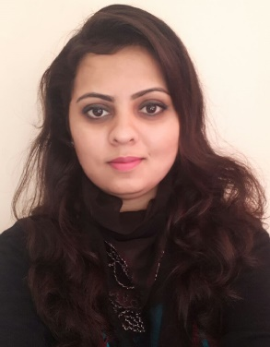
NAME - HARMANPREET
D.O.B- FEB. 03, 1991
NATIONALITY – INDIAN
MARITAL STATUS – MARRIED

E-MAIL: Harmanpreet.381660@2freemail.com
Seeking an Asst. Managerial Position-Human Resources/Administration in …
Target Sectors: IT/Retail/Construction/Telecom e.t.c.

Professional Summary:

Dedicated and focussed professional manager who excels at prioritizing, completing multiple tasks simultaneously. Specialize in organizing events, administrative support, maintaining business relationships. Committed to delivering high quality results with little supervision. Energetic, organized and professional.

Highlights Key Skills:

- Organizational Development
- Resourceful, Goal Oriented
- Strong problem solver and Self directed
- Professional and mature
- Forecasting and Planning
- Impactful email and content writing.
- Performance Appraisal
- Compensation Management
- Employee Welfare/Handling Employee Grievances and Employee Relations.

Work Experience:

- Abhimanu’s IAS Study Group, Sec-25 D, Chandigarh(INDIA) (Sep, 2015-March, 2017)

Operations Remote Centre Head

- ManagedCentre facilities,handling IT related issues with the classrooms.
- Handled huge responsibility of Hoshiarpur Centre with dedication including administrative activities, visitor exploration, counseling and admissions.

- Maintaining electronic and physical data files and coordinate with Head office.

- Telcocrats Technologies-Phase8, Ind. Area, Mohali(INDIA)(March, 2015–Aug, 2015)
HR / Administrative Incharge

- HR Responsibilities of providing resources to the organization.
- Conducting Interviews for the job seeking aspirants.
- Dealing with management of different colleges and universities.
- Handling Personality Development and Communication Courses for Graduate Trainees,
- Documentation and Data Keeping.

- Sony Mobiles Pvt. Ltd.-Hoshiarpur(INDIA)(July, 2014-Nov, 2014)
Shop Floor Executive
- Responsible for walk in customer queries regarding Product’s technical aspects and demonstration

- Svimtech Software Pvt. Ltd., Ind. Area, Phase 8, Mohali(INDIA)(Sep, 2012-Oct, 2013)
HR /Administrative &TDC Manager.
- Performed responsibility as part of Interview panel.
- Managed Training & Development Area.
- Head of team responsible for conducting seminars on latest trends of technologies for institutions
- Managed end to end responsibilities and maintained business relationships.

Education:

2012 | Bachelor of Technology (ECE) | PTU, Jalandhar(India) | 76 %
2016 | MBA: HR & Personnel  Management | Symbiosis University, Pune (India) | 67 %

Achievements:

- Conducted seminars on Cloud Computing at top 20 Engineering Colleges of Punjab region(LPU,CGC,QUEST,Rayat-Bahra,SBS,KC,SVIET,GZSIETetc)
- InaugratedGOOGLE club with Team of Svimtech Software atRayat-Bahra University Mohali ,INDIA.
- Received Award Recognisation for achieving 3rd rank for Hoshiarpur Branch among 15 othercentre Branches of Abhimanu IAS Group (India)

