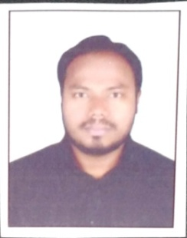
Curriculum Vitae

SANAULLA
E-mail id: sanaulla.381683@2freemail.com

SUMMARY
- Employed with Shree Srinivasa Transport Co., as an Accountant-cum-Cashier, India.
- Skill in exercising initiative, judgment and decision making in solving problems and meeting organizational objectives.
OBJECTIVE
- To associate myself to work in the reputed organization that gives scope to update my knowledge and skills in accordance with latest trends and be a part of team that dynamically works towards growth of organization.
WORK EXPERIENCE
01-nov-2014 to 10-may-2018.
ACCOUNTANT & CASHIER
Shree Srinivasa Transport Co.,
.
JOB RESPONSIBILITIES:

- Welcome the vendors with a smile as they enter into premises
- Proactively ask vendors how they can be assisted
- Provide vendor with information that they need
- Explaining the charges applicable for the transport of their goods
- Collecting the cash and recording it into the books.
- Reconciling the amount collected with the invoices issued
- Providing the reports to the Manager at the end of the day.
- Ensuring all the requirements are met as per the need.
- Payment of taxes as per the rules of the Local Government
- Train the other workers to work as a cashier
EDUCATIONAL QUALIFICATION

Bachelor of Commerce, B.COM computers KAKATIYA UNIVERSITY,
WARANGAL, INDIA, Graduated April 2013.

COMPUTING SKILLS

Tally ERP 9
MS Office
Advance Excel s

PERSONALITY TRAITS

- Strong leadership and motivational skills
- Ability to handle pressure
- Excellent in communication both in written & verbal
- Ability to handle the team
- Good Analytical and presentation skill.

INTERESTS
- PLAYING CRICKET & CARROMS , SWIMMING

PERSONAL DETAILS
Date of Birth : 20TH June, 1993
Marital status : Married
Languages Known : English, Hindi, Telugu and Urdu
Nationality : INDIAN
License : Light Indian driving license & International Driving Permit.
Professional flexibility:

Willing to travel, relocate or work overtime if the work obligations demand so.

