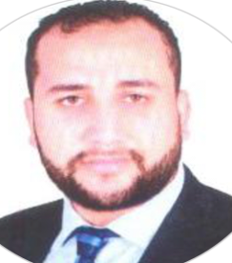
Job title: waiter \ sales
Address: Dubai , United Arab Emirates .
Email: shosha.381735@2freemail.com

Objective
To work in a challenging environment as a waiter, where I will be able to provide prompt and courteous service to the customers of a restaurant, cocktail lounge or club.
Job Experience
El-Tersana café and restaurants , Waiter- (May 2015 - 2017).
Main Duties:
- Responsible to take orders and assist the cook to prepare food as per order of customers.
- Providing effective supervision of all food and beverage services.
- Responsible to prepare recites and collect payments from the customers.
Paris boutique , Sales - (July 2017 - April 2018).
Main Duties:
- Provided customer services for up to eighty customers every day.
- Assisted customer in determinations.
- Applying upselling skills to customers .
- Assisted the manager to clean and close after the hours.
Key Skills and Strengths
- Professional work ethic.
- Upselling skills.
- Excellent written and verbal communication skills.
- Ability to work in a team.
- Sales and marketing skills.
- Customer service skills.
Academic Qualification
- High School Diploma.
- Pursued Bachelor of Science at Assiut University 2015.
Personal Details
Date of Birth: 1st August, 1993.
Languages: Arabic,English.

