Resume for the post of Physical Education Teacher/ Basketball coach

SOJI
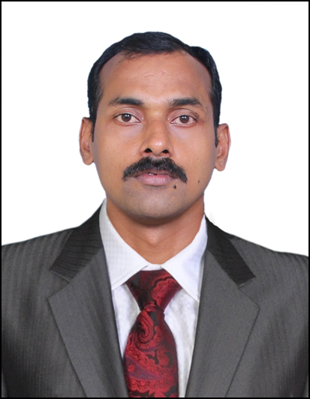
E-mail: soji.381785@2freemail.com

Visa Status. On visit for 3 months.

OBJECTIVES :-

To accept any position of which I am qualified that provides challenges and opportunities for additional training and healthy learning.

EDUCATIONAL QUALIFICATION

Graduation -Bachelor of Physical Education 2015 - 2017
(University of Mumbai- (2 Year course))
- Bachelor of Business Management 2014
(Kakathiya University)
Senior Secondary - University Of Calicut 1996 - 1997
10th Class - Board of Public Examination Kerala 1995
Additional - Physical Trainer Capsule Course
Courses (Indian Navy School of Physical Training)
- Leadership Course Certificate (Indian Navy)
- Certificate Course in Sports Coaching (Basketball)
(Sports Authority of India)
- Physical Conditioner Course
(Armed Forces Sports Medicine Centre)
- Life Guard and First Aid
SKILLS
- Good relationship management skills and natural problem solver
- Possesses great stamina enthusiasm.
- Flexible and great team player, with the ability to work to tight time scale.
- Proven Leadership & Management skills.
- Flexible and eager to learn new skills.

EXPERIENCE

PROFESSIONAL EXPERIENCE
17 Year experience as National Player, Trainer, Coach and Physical Conditioner with Indian Navy.
One year experience as Physical Education Teacher and Basketball Coach in Alphonsa School India from June 2017 to March 2018.

PLAYER
- 03 Years Played for Nationals (02 Times Gold Medals).
- 10 Years played for Indian Navy.(05 Silver,04 Bronze)
- 03 years Played for University of Calicut.
- 02 Years Played for Kerala State.
- Participate Inter SAI Basketball Tournament.

COACH
- Alphonsa School Thamarassery, Kerala 2017
- Indian Naval Academy team Coach for Bhakshi Cup on 2012.
- Eastern Naval Command team Coach on 2011.

PHYSICAL
CONDITIONER

- 05 Years Indian Navy Basketball Team Physical conditioner.
- 01 Year Services Basketball Team Physical Conditioner.

REFEREE
- 03 Years Senior Nationals Championship.
- 01 Year Junior National Championship.
- 01 Year Sub Junior National Championship.

PRESENT
EMPLOYMENT

- Workng in Alphosa School Thamarasserykerala, India as physical education teacher cum basketball coach

COMPUTER SKILLS

- Working knowledge in windows OS and MS office.

PERSONAL DETAILS

Gender : Male
Marrital Status : Married
Date of Birth : 30/03/1979
Height & Weight : 6 Feet 3 Inches, 92 Kg
Languages known : English, Hindi, Malayalam.

