





SYED

MBA / BCA

E-mail :- syed.381792@2freemail.com

PERSONAL GOAL:-

To make a successful career with vibrant organization which allows me to put my competencies to the best use, where I will be encouraged to set higher goals and pursue them in the field of Sales & Marketing.

SKILLS & PROFICIENCIES:-

Communication: - Good communication skills with convincing and reasoning
power 

Managerial: - Comprehensive problem solving abilities, willingness to learn, and have the ability to work as a team leader

Leadership: - A zest for work. Ability to understand the group potential and lead accordingly in order to achieve the goal

Proficient in Coordinating with the people

Computer Knowledge:-Proficient with MS Office applications and other Programmes like C++ and SAP

ACADEMY RECORDS:-

 | S.N. |  |  | Education |  |  | Institution/University |  |  | Year of |  |  | Class
 |  |  |  |  |  |  |  |  |  | Passing |  |  | Obtained
 | 4. |  |  | MBA (Masters of |  |  | Presidency College /
 |  |  |  | Business |  |  | Bengaluru University |  |  | 2017 |  |  | Second
 |  |  |  | Administration)
 | 3. |  |  | BCA (Bachelor |  |  | Vivek Anand Institute of |  |  | 2013 |  |  | First
 |  |  |  | Computer Application) |  |  | Management / Gulbarga
 |  |  |  |  |  |  | University
 | 2. |  |  | Pre-university |  |  | Chandrakant Patil pre- |  |  | 2010 |  |  | Second
 |  |  |  | College |  |  | university
 |  |  |  |  |  |  | College,Gulbarga
 | 1. |  |  | High School |  |  | Mount Carmel Convent |  |  | 2007 |  |  | First
 |  |  |  |  |  |  | School,Gulbarga

PROFESSIONAL EXPERIENCE

Company Name | : | Johnson Diversy India Pvt Ltd. - Bangalore, India
About | : | Leading organization for hygiene and cleaning that
 |  | integrates chemicals, floor care machines, tools and
 |  | equipment and a wide range of technology-based value
 |  | added services.
Designation | : | Sales Executive
Duration | : | July 2013 Up-to January 2015 (1 Year & 6 Months)
Job Responsibilities:

Indentifying business opportunities with various customers.

Planning and organizing client visits.

Selling products and establising contacts and developing long relationships

with customers.

Generating lead sales.

Preparing quotations with adequate product data and pricing.

Follow up on purchase orders from clients.

Setting up meetings with potential clients and provide product presentations.

Sending product introductory mails to customers.

Updating and follow up with clients on information new products, recommendation, guidance and service improvements. Preparing monthly sales reports and presentations.

Contributing to the team effort to accomplish sales targets.

Maintaning records of customer interaction, process customer accounts and filing documents.

Resolving customer complaints

Negotiating contracts and packages.

Updating the CRM System

Working on monthly sales and revenue targets set by the manager Attending exihibitions, events and conferences for special sales promotions.

Page 2 of 4

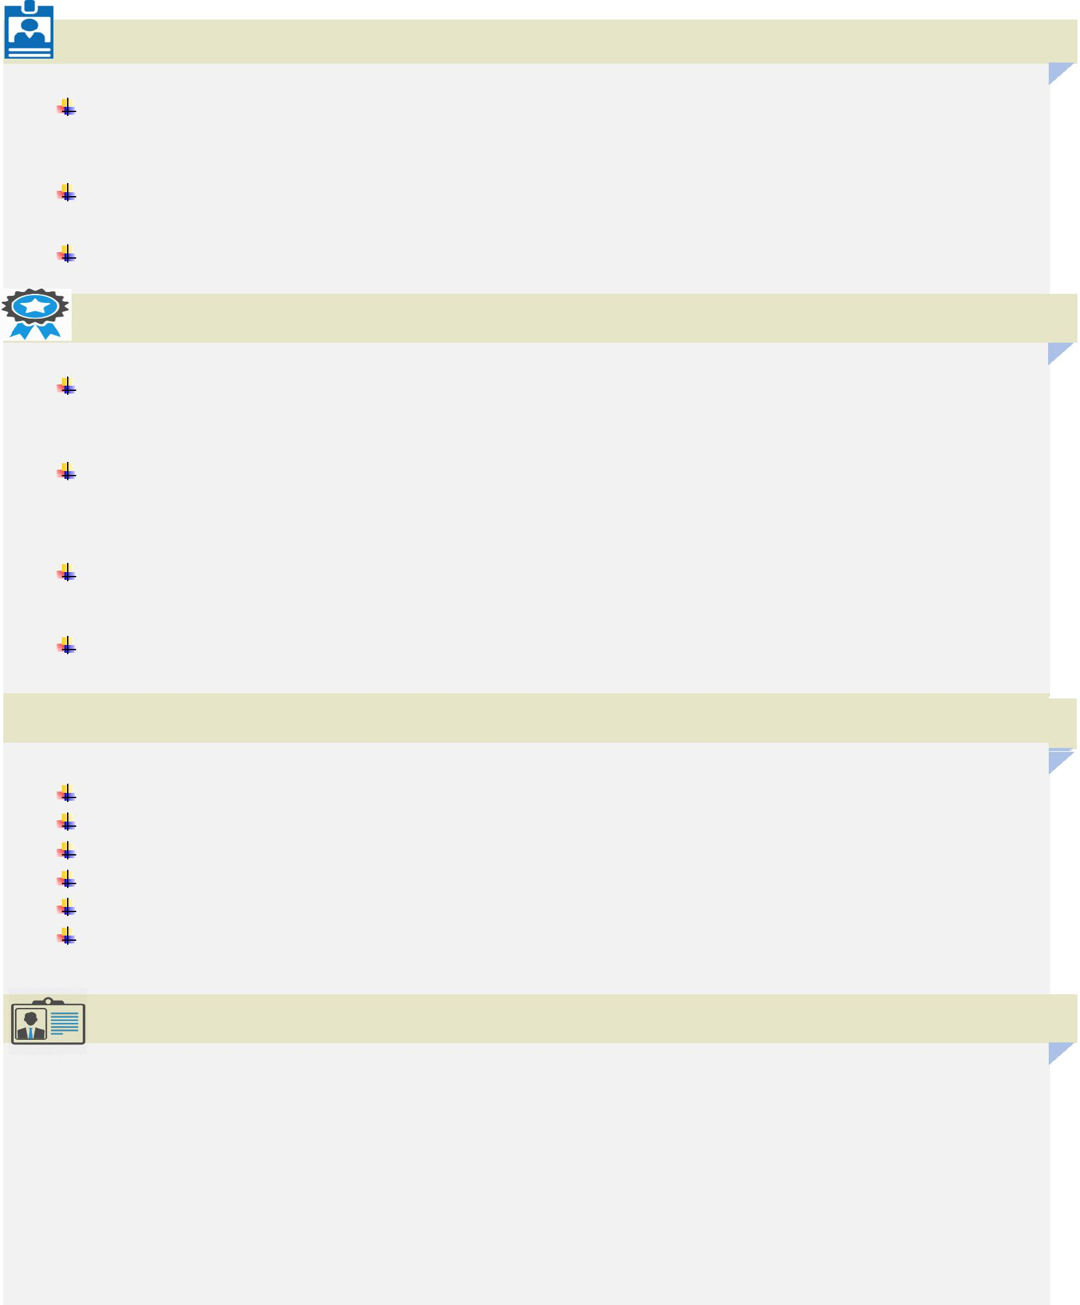
ACADEMIC PROJECTS, TRAINING AND TECHNICAL ACTIVITIES: -

Internship at Alticus Consulting:Study on emotional intelligence as a criteria in selecting managerial candidates.

Underwent SAP training.

Executed a final project during BCA titled “Network Monitoring, 2013.”

PERSONAL ACHIEVEMENTS:-

Was elected as a “Core Committee Member” who was given the responsibility to organize the college cultural fest VIDYUTH 2015, which was a success.

Received numerous awards & appreciations for Dancing Skills & showcased by talent during many proportional events.

Participated in Lean Body Building Competition.

Started a small scale Restaurant in Bengaluru.

INTERESTS AND KEY SKILLS:-

Dancing,Gymnastic & Travelling.
Good communication skills

Negotiating skills

Customer service orientation
Adaptibilty

Initiative to approach customers in positive manner

PERSONAL NARRATIVE:-

Date of Birth: | 12th October 1991.
Languages known: English, Kannada, Hindi & Urdu.

Nationality: | Indian
Religion: | Islam
Marital Status: | Single

Page 3 of 4

Present & Future Vision:-

First and foremost, I want to contribute as much as I can to your organization.

"In upcoming 3 - 5 years I hope to be working with an employer in an increasingly responsible position, which enables me to utilize my talents and work closely with my colleagues in solving important problems. I see myself taking on new and exciting challenges in an enjoyable environment and hopefully hopefully this will be with your organization.

Declaration:-

I hereby declare that all the information furnished above is true to the best of my Knowledge.

(Syed)

Page 4 of 4

