Resume

Thouraya
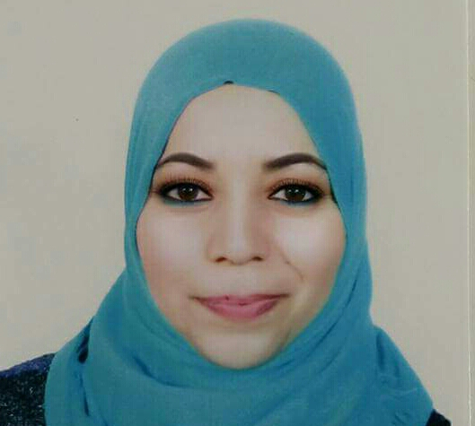Thouraya.381803@2freemail.com
Address: Near ADCB Metro Karama, Dubai

PROFESSIONAL OVERVIEW

Teacher 2012-2013 Salim school, Tunisia
Teacher 2014-2017Almanhal school, Tunisia

Objective
I am motivated and ambitious and I would like my students to appreciateand understand the importance of the English language in our daily lives .I believe in a strong communication between a teacher and his students and encourage the children to express their ideas verbally and through writing and I’m looking to obtain a job at school located in UAE

SPECIAL SKILLS

- Coordinating power and to mingle with different multi culture people
- communication skills
- Ambitiousand perfectionist
- Good team-work communication
- Sense of responsibility
- Dedicated to teaching students
- Professionalism
- Respectful
- Patient with students
- Highly adaptable

LANGUAGES KNOWN

Arabic : Native language
English : Fluent
French : Fluent

EDUCATIONAL QUALIFICATION

Manouba University of Arts and Humanities

RESPONSIBILITIES

- Teach the assigned courses in accordance with the course outlines and recommended textbooks. A teaching program should integrate listening, speaking, reading and writing
- In a semester, at least 3 or 4 evaluations are required in order to motivated the student to work hard during the whole year
- Run the student journal where the children are encouraged to publish anything from poetry to science fiction novels

ACHIEVEMENTS

Initiated the student journal which helped a lot of students to express themselves through poetry and novel

PERSONAL INFORMATION

Age and date of birth36, 17/08/1981

Religion- Islam

Marital statusmarried

NationalityTunisian

I here by declare that all the information stated above is true to the best of my knowledge and belief.

