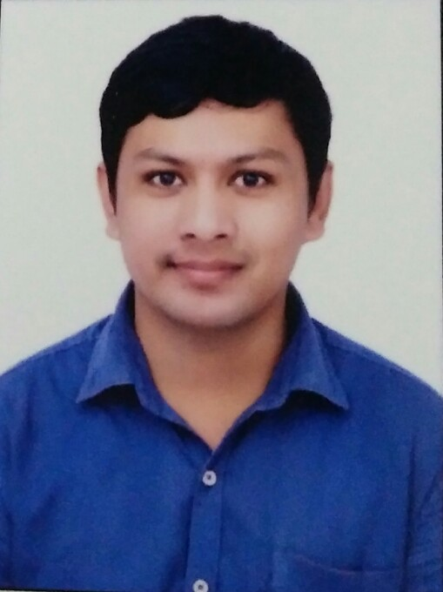
RESUME
AMARJEET
Date of Birth 08-09-1985
Email- amarjeet.381808@2freemail.com

OBJECTIVE
Looking forward to work in an organization that will give me a chance to learn new challenging things as well as opportunities to implement my knowledge, appreciate my contributions and reward my efforts, having a team of professionals and quality environment where my knowledge and experience can be shared and enriched.
EDUCATION
F Y B.COM 2008 C.D.J College of Commerce Pune University
Inter College (HSC) 2005 C.D.J College of Commerce Pune University
High School (SSC) 2003 DahanukarVidyalayaTilaknagarPune University
TECHNICAL QUALIFICATION
DIPLOMA IN DIGITAL ELECTRINICS SECURITY SYSTEM
TECHNICAL SKILL SUMMARY
Computer Hardware and Networking Computers Assembled Laptop Servicing Printer Servicing peripherals and Networking Setup of office college Network Maintenance and Fixing Network Fault and configure Network Printer Shearing and Connected Installation
Various software installation like Windows 98, XP, Vista, Windows7,Windows 8 Windows 8.1,Windows10 installing Windows Server 2008 installing. MS Office Photoshop, Corel draw tally and ERP 9, Autoad Quick Heal, escan Net Proctor Antivirus
Configuration and Troubleshooting Microsoft Outlook Like accounts Create Configure Backup /Restore email configure on mobile, Video Conference (VC) Device and Projector Connecting on Meeting
Basic knowledge Microsoft Word Excel Corel Draw Photoshop Tally Erp
CCTV Cameras, DVRs, NVRs, other hardware. Provide technical support to end users covering all software and hardware related issues. Responsible for installing CCTV camera systems including of structured cabling, Termination and configuration and Laying of structured CCTV cameras installation, DVR/NVR configuration, access and support. IP Camera PTZ Camera analog (Dom/Bullet/PTZ) Installation Configuration Access on Mobile, Laptop & Computer Live View
Cat 5e, Cat 6 CCTV Cable Fiber Optical Cable structured installation, termination, and testing. Drilling Piping
Installation and Troubleshooting Video Door Phone, Motion Detector, Fire Alarm and Smoke Detector System Biomatric Time attendance and access control Machine. Communicates with individuals by phone and email to solve technical problems Basic Knowledge of Microsoft Word Excel Photoshop Corel Draw Tally

SUMMARY Of WORK EXPRIANCE
- DESKTOP /CCTV Support Technician Work as Attivo Protezione Pvt.Ltd (Jan 2014 –May 2018)
Total 35 Computer Troubleshoot, repair, maintain, install and perform testing activities on various computer equipment, peripheral
Configuration and Troubleshooting Microsoft Outlook Like accounts Create Configure Backup /Restore email configure on mobile
Network Maintenance and Fixing Network Fault and configure Network Printer Shearing and Connected
Responsible for installing CCTV camera systems including of structured cabling, Termination and configuration and Laying of structured CCTV cameras installation, DVR configuration, access and support. Camera IP Camera PTZ Camera analog (Dom/Bullet/PTZ) Installation Configuration CCTV Camera Access on Mobile, Laptop & Computer Live View
Knowledge of Video Door Phone, Wireless Intrusion Alarm, Fire Alarm System Biomatric Time attendance and access control
CCTV camera monitoring Daily Report Send to Managing Director by Mail Whatsapp our Various Locations offices Sites Daily Clients User Backup on Server Machine
- Desktop Support Engineer Work as ION Exchange PVT.Ltd (Auguest 2012 — Oct 2013)
Total 125 Computer Troubleshoot, repair, maintain, install and perform testing activities on various computer equipment, peripheral, (We are four Engineers)
Installation Server 2003 Active Directory Setting up user accounts, Promissions and Password Managing Group Policy
Configuration and Troubleshooting Microsoft Outlook Like accounts Create Configure Backup /Restore email configure on mobile
Maintenance and Fixing Network Fault and configure Network Printer Shearing and Connected
Video Conferencing Device connecting between sites.
Daily Clients User Backup on Server Machine
Computers Assembled with all Type of Microsoft software installation Laptop Servicing Printer Servicing peripherals
Provide technical support to end users covering all software and hardware related issues.
Cat 5e, Cat 6 structured cable system installation, termination, and testing. Networking Setup of office college Network Maintenance and Fixing Network Fault and configure Network Printer Shearing and Connected TION
I hereby declare that the above-mentioned information is correct up to my knowledge and I bear the responsibility for the same.

