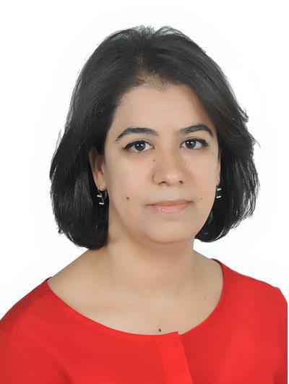
Hasna

Date of birth : 16.04.1983

Nationality : Moroccan

Contact :
E-mail hasna.381818@2freemail.com

Objective

To contribute my knowledge and skills in a dynamic and fast growing firm.

Performance Summary

Dexterous and skillful dental laboratory technician with a 12+ ears e perie ce i a comprehensive range of dental technology and services. Full command on prosthetic dental lab operations, equipment adjustment. Expert in purposive dental tools

Professional Experience

- License : DHA Dental Technician License

2015 to Present ‘Horizon Dental Lab’ -Dubai-UAE

Pressing ceramic

Veneer

Inlay

Onlay

Full shell

Wax-up to metal

Full metal crown

Inlay

Onlay

Post

Bridges

Zircon

3 shape scaning and designing for crowns and bridges

Ortho Scan (Exocad)

Implant cad/cam

2005-2015 ‘ La Couronne Laboratory’ -Tangier-Morocco

Wax-up to metal

Ceramics

Opaque

Build up

Glaze

Denture

Full denture

Partial Denture

Repair the complet and partial denture

2004 | ‘Prosthetics Dhaib Laboratory’ -Casablanca-Morocco.
 | Training in fixed dental.
2003 | ‘ksar prothése Laboratory’ -Casablanca-Morocco.
 | Training in removable dental Prosthetics.

Created plaster representations for the construction of porcelain crowns and bridges.

Technical Expertise

- Handle Preparatory operations to design the prosthetic element.

- Techniques of Carving with wax.

- Fabricate and repair the complete and partial dental Prosthetics removable.

- Create crowns, veneers and bridges.

Education

2002-2004 | Dental Technician.
 | Graduated fro | I stitut des Etudes des M tiers de Sa t et de Proth se
 | Casablanca - Morocco.
2002 | Baccalaureate diploma.

- Languages

Arabic

English

French

