CURRICULUM VITAE
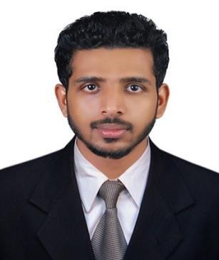

MOHAMED

Email: mohamed.381819@2freemail.com

Objective

Seeking a career to utilize my knowledge, personal skills to gain comprehensive understanding of a reputed organization so as to take responsibility and contribute significantly.

Education

- 2015 – 2016: MBA (HR & MARKETING) FROM BANGALORE UNIVERSITY, KARNATAKA, INDIA.

- 2011 – 2014: BBA (BACHELOR OF BUSINESS ADMINISTRATION) FROM KANNUR UNIVERSITY, KERALA, INDIA
- 2010 – 2012: PLUS TWO (12TH) COMMERCE FROM CBSE BOARD, INDIA
- 2009: 10TH FROM KERALA BOARD, INDIA

Experience

HR ASSISTANT ~ F2H TECHNOLOGIES, BANGALORE, INDIA (AUG- 2016 TO JAN- 2018)

- Proactively provided assistance and support to employees on HR issues & queries.
- Assumed total accountability for building long term relationships with key clients.
- Tasked with developing recruitment process, handling performance appraisal and follow up.
- Accountable for capturing of Input related attendance, Leave details, Reimbursement details, Exit details and ensured background and reference checks were completed.
- Put in distinguished efforts in setting appointments, arranging meetings, joining formalities and maintaining employee’s personal data files.
- Systematically maintained & devised Office system and handled administrative matters of the company.
- Advised Management in appropriate resolution of employee relations issues.

Academic Projects Undertaken

COMPANY: PRAKRUTHI FOODS , BANGALOURE, INDIA.

A case study: A STUDY ON LOGISTICS OF PRAKRUTHI BRAND FOOD PRODUCTS IN BANGALOURE CITY (MBA PROJECT)

THALIPARAMABA WEAVER’S CO.OP LTD IN KANNUR, KERALA, INDIA

IT Credentials:

- Proficient in working on MS Office (windows XP, Windows 2007, 2010, etc)

- Three months course in LCS from LAP TECH Computers

- Six months course in CII-IL

Skills Set:

- Strong problem solving skill to resolve issue quickly and fairly.

- Excellent presentation skill.

- Great sales and customer service skills in person or over the phone.

- Willingness to learn.

- Organized and analytical in all work to avoid mistakes.

Achievements:

- Participated in “CSR Activity” 2015, Bangalore

- Participated in “Blood Donation Camp” 2015

- Participated in the student conclave 2016 on the theme "Dissertation Guidelines - Ideation to Execution"

Hobbies & Interests:

- Traveling (long drives).

- Music, Movies, Sports Events, etc

- Playing Badminton & Football.

Personal Details:

Date of Birth | : | 08/04/1991
Nationality | : | Indian
Gender | : | Male
Marital Status | : | Single
Visa Status | : | Visit Visa (ex :28-08-2018)
Languages know | : | English, Hindi, Malayalam

Page 2

