******CARRICULUM VITUE ******

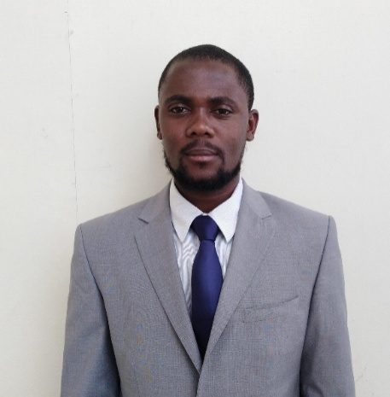
EDSON

BIOGRAPHY
Address: Abu Dhabi
Nationality Ugandan
Email: edson.381835@2freemail.com
Marital status Married
Gender Male
Date of birth. 02-03-1991

EDUCATION
Certificate in Information and technology
Driving permit for Uganda

Skills, Knowledge, Attributes and Abilities
Communication. I have a knowledge to how to communicate to all kind of people in all conditions
I have been working withAirtelUganda as a taller for 1 year
I have ability of day to day running of any arrange any fault in my work.

Working experience
Between 2015 to 2016driverfor Airtel telecommunication company.
Now I work with Armed forces Cooperative Society (Afccop) Abu Dhabi khalifa city
LANGUAGE
- English – Written and spoken
HOBBIES
- Studying about road directions on GPS
- Playing racing games
- Interested in improving my driving skill
I kindly request for a position/vacant of driving in your company IN SHAA ALLAH let me that my CV will be put under your successful considered candidates.

******** I Remain Twijukye Edson/ IDRIS ********

