 |  | CURRICULUM VITAE
Name: | TIMOTHY
Email: | Timothy.381867@2freemail.com
Nationality: | Cameroonian
Date of Birth: | 10/07/1986
Gender: | Male
Visa Status: | Resident visa
Languages: | English / French
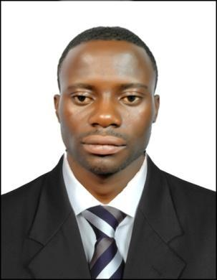

POSITION : COMMERCIAL MARKETING / ONLINE SALES AND ADVERTISEMENT

OBJECTIVE

A reliable, trustworthy and conscientious customer service agent, who is able to multitask, handle pressure, work as part of a team and most importantly inspire customers to make a purchase, with a unique enthusiasm and an inspirational style, I have used my extensive experience of customers industry to develop superb organizational, problem solving and customer skills, the urge to set targets and achieve them on time. I am an exceptional person who can explore new territories and push existing limits in the search for customers. I am currently looking for a suitable Commercial Marketing / Online Sales and Advertisement Agent opportunity in your company that will not only challenge me professionally but also allow me to develop knowledge & potential further in term of quality services.

To offer quality services to customer

To always listen to the customer

To increase customers satisfaction and a unique experience

With all these quality policy applicable respectively and extra mile work of daily duty will enable the smooth functioning and growth of the company to higher height

EDUCATIONAL BACKGROUND WITH DATE
2013 – 2011: Associate of Science: Computer Studies, Business and Communication Management University of Lagos State Nigeria

20011 – 2009: Grade one teacher training certificate (CAPIEMP) GBTTC Kumba

2009– 2007:

2007 – 2003:

Advance Level, General Certificate of Education GHS Kumba Ordinary Level, General Certificate of Education GHS Kumba

2000 – 1993: First School Leaving Certificate, Catholic School Nwangri

PROFESSIONAL QUALIFICATION

2014 - 2013: Professional training in photography, cinematography and designer in MAXTRON PHOTO EFFECT Port Nigeria

WORK EXPERIENCE

2017 TILL DATE: DAR AL HURIAH TRADING LLC, Sharjah UAE Industrial Area 12

- Director of online marketing and commercial sales

- Designer and photographer and advertisement
- Director’s Office assistant
- IP Camera and CC TV Technician

2016 – 2014

- Work as Technical Controller generator and pump BOCOM Petroleum S.A Nkambe / Nkwen Bamenda Cameroon

- Director of photography editor and production manager Millennium TV Nkambe Cameroon

2014 – 2013: Assistant Manager Bayland TV Yaoundé Cameroon

2011 TILL DATE: CEO of 21st Century Digital World of photography and cinematography Nkambe Cameroon

DUTY
- Update customers of latest product and ongoing promotion

- Design animation for publicity on social media.

- Replies customers question on social media and give them more details about our product.

- Design flyers for outdoor marketing and advertisement to get more new customers.

- Follow up indoor customers to increase their desires for more consumption of our product

- Keep inviting customers through SMS and on social media messages and post to visit us

- Draw a platform to offer gifts to customers who win promotion and also gift to regular customers and those who buy in large quantities

- Prepare monthly and annual budget.

- Prepare weekly and monthly reports.

- Design website for online sales for customers who not free to visit our warehouse.

PERSONAL SKILL

- Good management, Inter personal communication and organizational skills.
- Ability to work quickly and independently with less supervision.
- Ability to work under pressure and meeting datelines.
- High self and career motivated.
- Team work.

HOBBIES
- Singing, Movies, Traveling, Sport (Football).

