RESUME
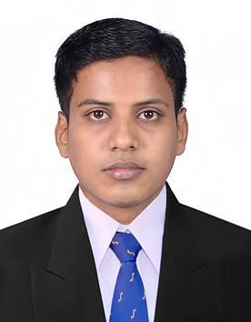

GANI

E-mail : gani.381876@2freemail.com

CAREER OBJECTIVE:

To pursue a highly rewarding career, seeking for a job in challenging and healthy work environment where I can utilize my skills and knowledge efficiently for organizational growth.

TRAININGS ATTENDED:
Organization : Dr. V Seshiah Diabetes Care and Research Institute, Chennai, India.
Designation | : Accounts Assistants
Duration | : 01st August 2016 - 31st December 2016
PROFESSIONAL EXPERIENCES:
Organization | : (CAMS) Computer Age Management Services Pvt. Ltd, Chennai, India.
Unit | : DSP Black Rock Mutual Fund
Department | : Purchase
Designation | : Assistant Processing Officer
Duration | : 02nd January 2017 – 30th June 2018

Role & Responsibilities - V Seshiah Diabetes Care and Research Institute, Chennai, India:
- Tally entries.

- Vendor Payment and follow.
- Bank Reconciliation Statement Preparation.
- Salary Processing.

Role & Responsibilities - (CAMS) Computer Age Management Services Pvt. Ltd, Chennai, India:

- To analyze the data quality in application.
- To receive the application to investor.
- To check all type of error.
- Daily transaction verification for more than 10lakhs valuable transaction. (we need to check the investor signature, Amount for every transaction)
- Bank mandate verification.
- Third Party Verification from Redemption request to Cheque.
- Purchase hold, Purchase Errors on high value.

- Following up AMC mails and solving the issues of the investor.
- Preparing Weekly Report on Error’s and sharing the same with immediate supervisor.
- Account statement generation and dispatch letter send to investor for their status of transaction in mutual fund.

ACADEMIC BACKGROUND:
- Master of Business Administration (MBA) Correspondence Finance under Bharathidasan
University.
- Bachelor of Business Administration (BBA) under Bharathidasan University.

SOFTWARE KNOWLEDGE:

- Tally ERP 9.0
- Ms Office

TECHNICAL QUALIFICATION:

- Typewriting ( lower - English)

KEY SKILLS:

- Good Communication skills
- Be able to work as a team and individually
- Insightful-high motivated to learn and experience
- Excellent in certain computer program (MS Office)
- Hard working, Enthusiastic and Honest

PERSONAL DETAILS:

Date of Birth

: 11th November, 1993

Sex

: Male

Nationality

: Indian

Marital Status

: Single

Visa Status

: Visit

Languages Known

: English, Tamil

DECLARATION:

I hereby declare that the above said facts are true to the best of my knowledge and
belief.

