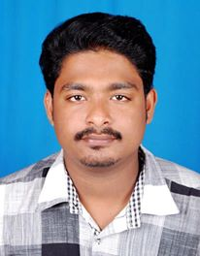
DEEPU
E-mail: deepu.381902@2freemail.com

Career Objective
Reliable, safety oriented Driver with 8 years hands on experience in light and Heavy bus driving committed to ensure the safety of passengers merchandise And vehicle.. Able to respond quickly in emergency situations.. ExcellentCommunication skills and proven ability to read map and use GPS system. Also worked as a transport co-ordinator

PERSONAL INFORMATION

Date of Birth : 20 may 1986
Nationality : Indian
Languages known : English, Hindi, Arabic, Malayalam,
Address for communication : Dubai

Educational Qualifications
- Secondary School living certificate
- Higher secondary school living certificate
Licence Details
- Issue date : 13/02/2011
- Expiry date : 12/02/2021
- Allowed vehicles; heavy bus and light vehicle.(3&6)
- Place of issue ; Abudhabi
Work experience
- Worked as fleet Supervisor cum driver in 2009 to 2013Binjaffar Transport Abudhabi
- Worked as a bus driver 2013 to 2014 in Lumen pipe line testing services Dubai
- Worked as a bus driver 2015 to 2017 in Penguin Engineering LLC in Dubai
PASSPORT DETAILS
Date of Issue : 17/06/2015
Date of Expiry : 21/06/2025
Place Of Issue : Trivandrum
Declaration:
I hereby declare that the above data furnished by me are true to the best of my knowledge.

