Amer  Amer.381911@2freemail.com  Date of Birth: 15-Sept-1986  Place of Birth: Damascus - Syria  Nationality: Syrian  Marital Status: Single  Visa Status: resident Visa  Emirates Driving License | 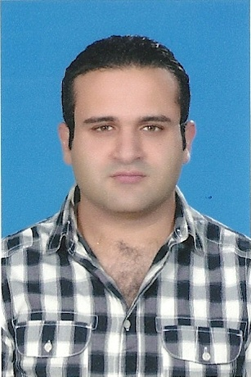

Objectives

Seeking an opportunity to capitalize on my Basic experience and build long-term career.

Education

July 2004 |High School Diploma in Science
- Grade 120 Score

Nov 2009 /Feb 2011|A+ - Auto cad 2008 – Photo Shop
- New Horizon Institute
Jan 2016 |- Auto cad 2015
- Sites Power Training Center
Experience

Sept-2004/Jan- 2007 | ManagerAssistant for aKitchen ware manufacturer
Al Lahham Decoration | Damascus- Syria- Daria
- Coordinate the operation and Support a team of 5 people.
- Customer support.
- Follow up the daily work of the team to make the delivery on time to the sites.
- Work As draft man using Auto Cad program to make an elevation drawing for the kitchen.

Feb-2009 / Jan-2011|Showroom Manager for a kitchen accessories
Al Waha Trading | Damascus – Syria

- Managed the operations and a team of 5 people.
- Coordinate with agents and business partners.
- Follow up on sales activities including invoicing and account receivables.
- Customer support.

Feb-2011 / July-2012 |Local Export Department manager
Al Haram Cargo | Damascus – Syria

- Managed a team of 8 people.
- Responsible of checking all invoices of the freight forwarders.
- Follow up the daily work of the team to make the delivery on time to the Distance.
- Coordinate with local freight forwarders agents and customs broker to get best price with best service.
- Follow up on sales activities including invoicing and account receivables.

Nov-2014 |Aluminum And Glass Company Supervisor
Al Haram Cargo | UAE–Sharjah

- Support And Lead a team of 3 people.
- Responsible of checking all sites work done.
- Follow up the daily work of the team to make the delivery on time to the Clint.
- Coordinate with Formanget job mission update .

Skills
- Languages Arabic (native tongue) and fair English.
- Computer Skills Microsoft Office, Al Rasheed Accounting Program, Auto Cad and Photoshop.

References
References are available upon request

