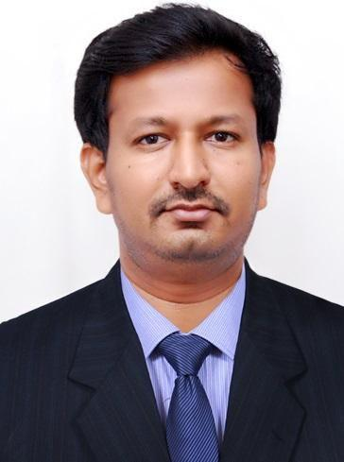
RESUME

CHANDRA

Email: ​Chandra.381923@2freemail.com

Objective:

- To apply my knowledge and skills in the field of Health Information Management

- Keep myself updated with advancement in the field of Health Information Management

- To be a part of a team that dynamically works towards the growth of the Health information in the health care industry.

Work experience:

1. | Institute | Father Muller Medical College Hospital
 | Position | MEDICAL RECORDS OFFICER
 | Duration | June 2016- December 2017
2 | Institute | Indiana Hospital & Heart Institute, Mangalore.
 | Position | MEDICAL RECORDS OFFICER
 | Duration | September 2014 – June 2016
3. | Institute | City Hospital & Charitable Trust, Mangalore
 | Position | STAFF NURSE
 | Duration | January 2011 - January 2012

Current job profile:

- Reviewing and evaluating existing policies, procedures and work methods on a periodic basis in consultation with administrator.
- Member of Hospital Quality Internal Audit team.

- Preparing Hospital Statistical Report for Medical Council of India (MCI)

- Implementation of 10th chapter {Information Management System} of NABH in MRD.

- Giving training to all the Nursing staffs about the documentation process etc.

- Preparation of Medical Records Manual.

- Involving in decision making with all the Heads of the department.

- Working for implementation of EMR in the hospital

- Reporting of all the Hospital Births & Deaths to corporation office.

- Member of Medical Records Audit & Core committee Team.

- Manages and coordinates a system for safeguarding and updating active and inactive patient medical records.
- Monitor the accurateness of patient records and documentation of patient visits.

- Reporting all communicable disease reported in the hospital to the district health surveillance office

- Serves as an advisor on Medical records policies and consultant to medical staff.

- Orients new staff to the relationship and interaction of medical records unit with other units of department.
- Evaluates performance, implements corrective action on areas needing improvement or re-training.

- Participates on applicable committees and recommends policy changes as necessary.

- Preparation of Monthly Hospital Statistical Data & sending it to the Top Management.

- Oversees the processing of subpoenas and depositions consistent with legal regulations.

- Preparation of Monthly Quality related indicators & sending it to the hospital Quality Department.

- Giving Training for the MRD staffs

- Coordinating with Quality Department for Hospital forms and to maintain the quality in the documentation and to develop the policy and procedures of Hospital Medical Records.
Education:

School of Allied Health Sciences, Manipal
Master in Hospital and Health Information Administration (MSc HHIA)
Manipal University, 2014

City College of Nursing, Mangalore, Karnataka
Bachelor of Science in Nursing(B.Sc Nursing)
Rajiv Gandhi University of Health Sciences, Bangalore, 2010

HHSIB Swamiji’s Higher Secondary, Edneer, Kasaragod, Kerala
​th​
Pre-University (12 )
Kerala Higher Secondary Education Board, 2006

Kendriya Vidyalaya,Vidyanagar, Kasaragod,Kerala
​th​
High School (10 )
Central Board of Secondary Education, 2004

Academic Project:
Patient satisfaction on Vajpayee Aarogyashree Government Insurance scheme: A Cross Sectional Study.

Certification :

ICD 10 CM certification from AMCI (Approved by Quality council of India)(Pursuing from 01/04/2018)

Workshops & Seminars:

- Attended Seminar on Continuing Health Information Education, 2012

- Attended 15 days Observation training in A.J Hospital Mangalore, 2013

- Attended 15 days Curriculum training in Manipal Hospital, Bangalore,2013

Career History and Exposure:

- Successfully completed 150 Hours of Postings in Medical Records Department of A 2000 Bedded Hospital, Kasturba Hospital, Manipal
- Completed 25 hours of ICD-10 and 15 hours of ICD-9cm Coding for Discharged Patient Records

- Completed 15 Days of Training at a Corporate Hospital, Manipal Hospital Bangalore

- Completed 84 Hours of Postings at Various Administrative and Clinical Services at a Tertiary Care Hospital
- Worked as Staff Nurse for a period of 1 year in City Hospital Mangalore, Karnataka.

- Completed 10 days of Training in ICD-10 Coding practice in Father Muller Charitable Medical College Hospital.

Skills:

- Ability to work in teams

- Prepare Hospital Statistics

- Adaptive to any atmosphere

- Hospital Quality Internal Audit team member

- Chapter champion of NABH - IMS chapter

- ICD-10,CPT, ICD-9 Coding

- Good Medical transcription skills.

- Handling of Health Insurance

- Research Skills, Conducting Open & Closed files audit

- Good verbal, oration and written skills.

- Good computer skills (MS Word, MS PowerPoint, MS Excel)

- Computer applications - Visual Basic, SQL,HTML

Personal Information:

Nationality | : | Indian
Sex | : | Male
Languages Known | : | English, Hindi, Kannada & Malayalam
Date of Birth | : | 14/08/1987

Declaration:
I hereby declare that, the above mentioned information is true to the best of my knowledge.

